Light Kit Installation
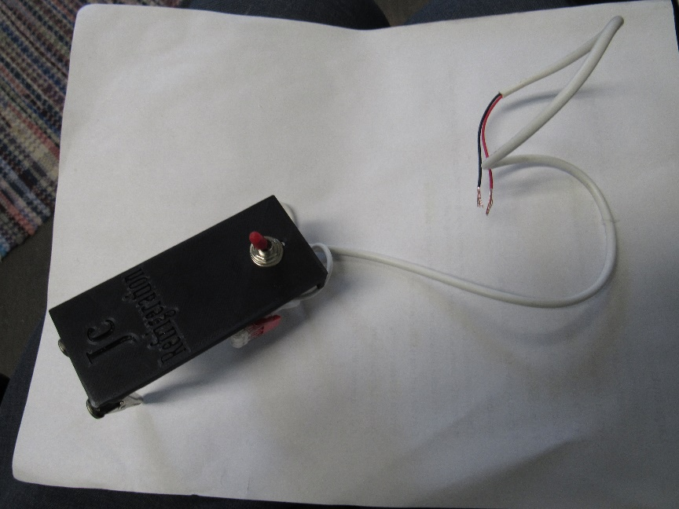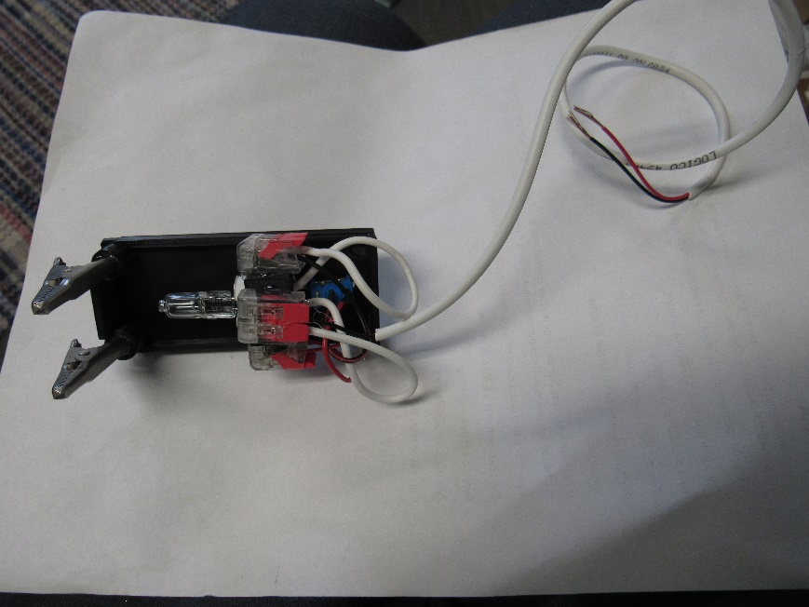
The light kit will get wired into the Wagos on the backside of the fin fan. So, turn the fin fan off using the switch and unclip it from the fins so that you can access the Wago connectors. There will be 3 Wagos on the back of the fin fan. One has a single red wire in each slot, the second has 3 black wires with 2 black wires in one slot and 1 black wire in the other slot. The third Wago has 2 red wires and 1 black wire in any combination.
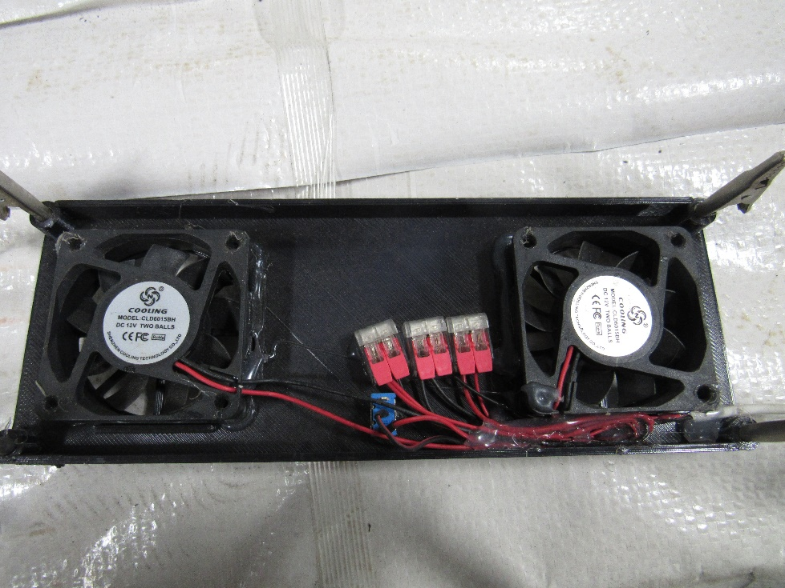
Find the Wago with the 2 single red wires (RA) and flip one of the tabs up to release the wire. Take the red wire from the light kit and twist it together with the red wire you just removed and then insert the two wires back into the Wago slot and flip the tab down to lock them in place. Now go to the wago with the 3 black wires (YA). Pull the tab up to release the single black wire and twist the black wire from the light to this black wire and insert both back into the Wago slot and push the tab down to lock them in place.
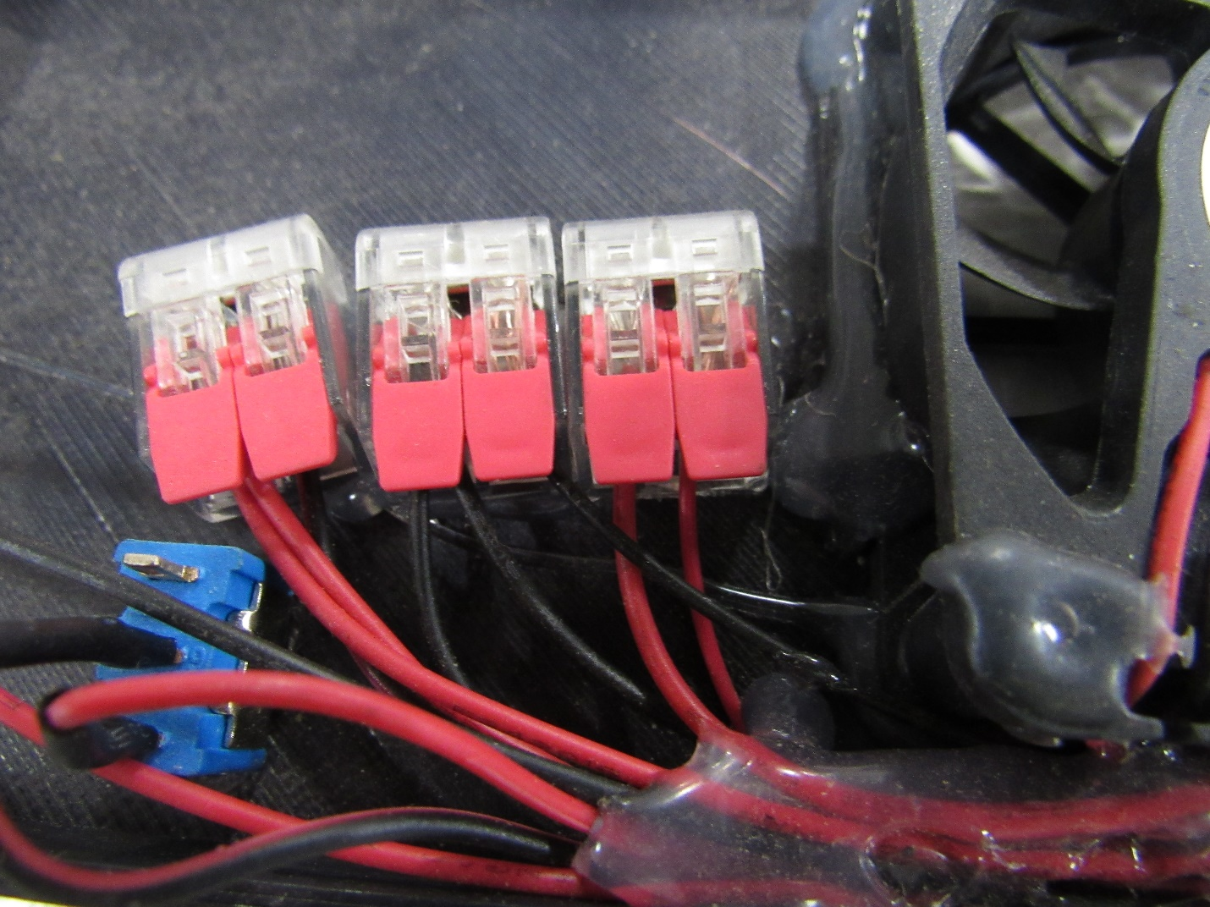
Then flip the switch on the light kit to make sure that bulb lights up. If everything looks good, clip the fin fan back on to the fins and also clip the light kit about 1-2 fins to the left of the thermistor.
This light kit will usually only be needed in cooler weather. This will give off just a little bit of heat inside the fridge compartment causing the compressor runs a little bit longer and this will give the freezer more time to get down to a temp of 0-10 degrees.

