HVAC 12V Cooling Unit for Models:
682, 683, 483, 482, 8682, 8683, 6082, 6083, 6182, 6183, 982, 9182, 983, 9183, 810, 841, 821, 822, 811, 843, 1095, 962, 9162, 963, 9163, 941, 643, 641, 621, 611, 610, 462, 463, 662, 663, 862, 863, 6162, 6163, 6062, 6063, N600

Jr and Jeremy Lambright
jcref@centurylink.net www.jc-refrigeration.com
Jc Refrigeration
Installation Manual

Good Day Friends, this is how it all begins, hope you find this helpful thru your installation.
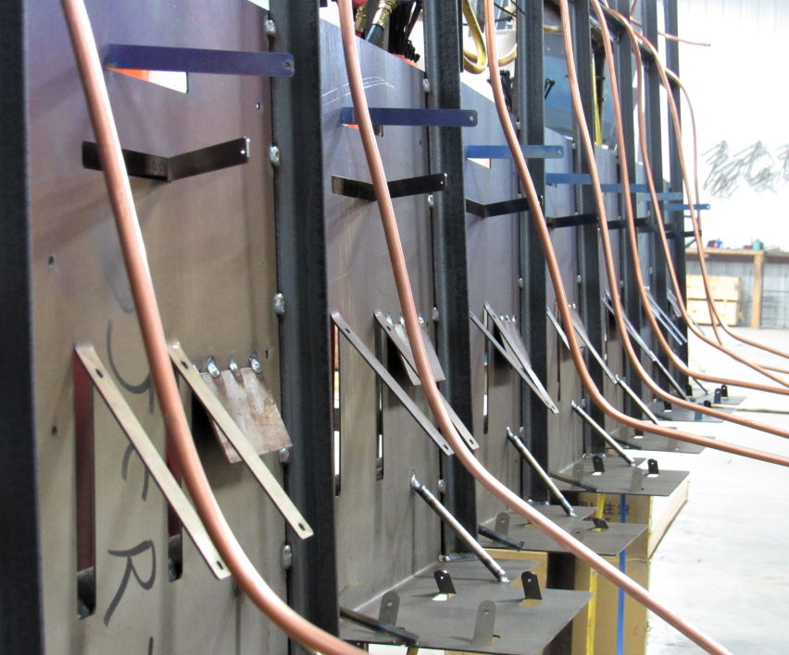Units prepped for compressors.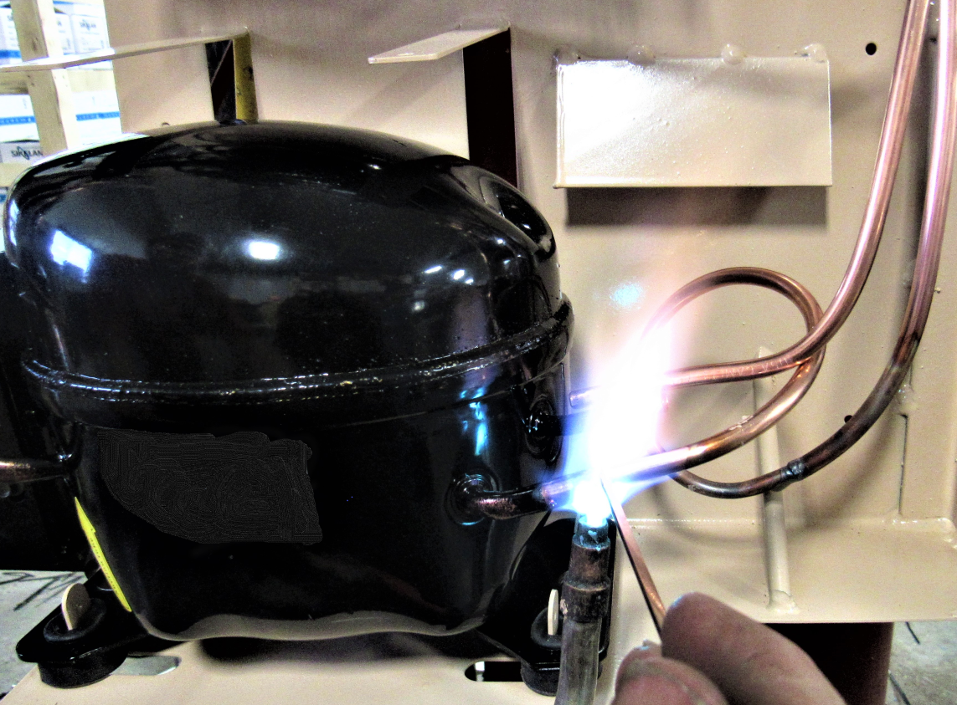 Brazed welded for strength.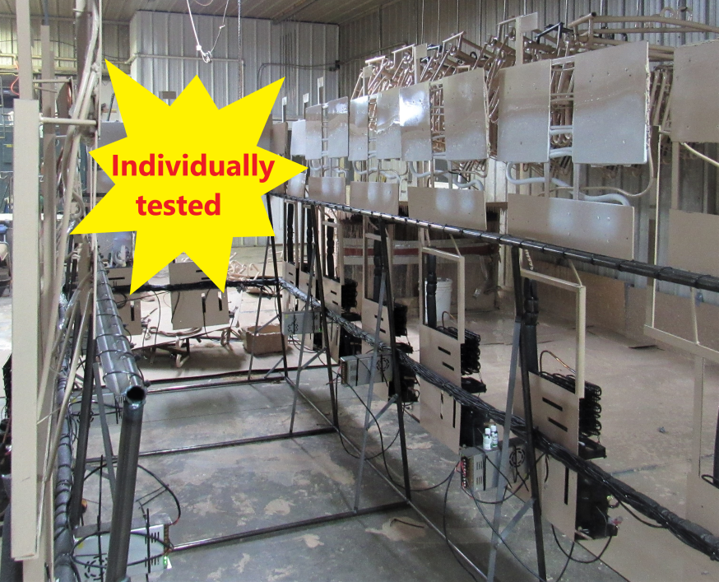

Tools needed to do the install:
Screw gun 5/16 ¼ Phillips wrench putty knife knife caulk gun zip ties
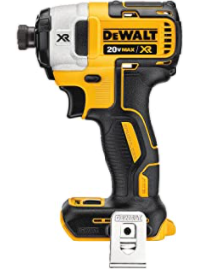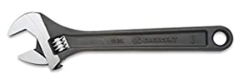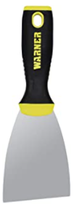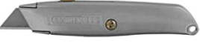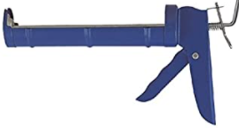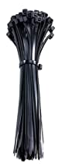

1 or 2
And enough time to think things thru at times, so don’t give up and hang in there to the end it will be all worth it. A cold fridge is about to be had!!
We at JC Refrigeration try to build these as easy to install as possible, and so these are DIY cooling units but please be aware tho that our upgrades might not look quite the same, and brackets, frames, hole plates might not always line up perfectly as fridge boxes can vary at times, and so some modifications, foam shaving or tweaking might need to be done at times to install it. A thing to remember is these are made out of thick steel tube and plates so some twisting or pushing into place is very normal and nothing to be alarmed about. We offer videos for the gas/elect and install manuals for the Hvac units to help you thru this install and feel free to send us a picture along with your question, and we will help you to the best of our ability.
JR & Jeremy Lambright

To start this process, begin by taking the cooling unit out of the box, if box appears to be damaged don’t panic as we foam package them into the box (YA) and so the box can be practically destroyed and the unit is still not damaged. So, when you take the box apart you will notice a spray foam packing inside and so this needs to be removed and then the unit will slide out. Inside the box you should have the cooling unit, and parts needed to do the install (RA)

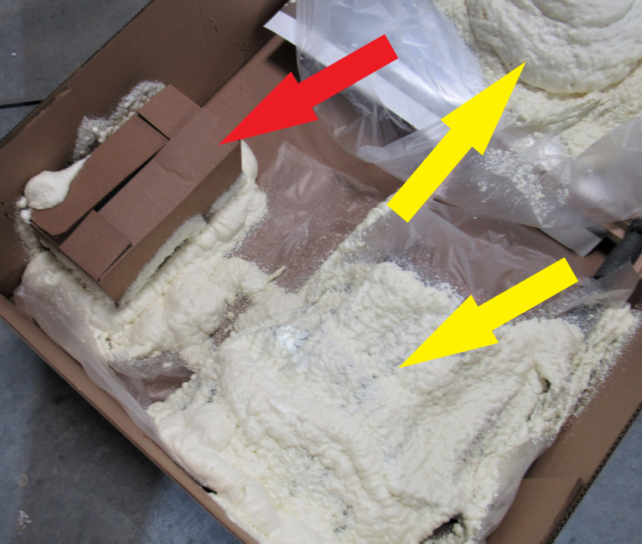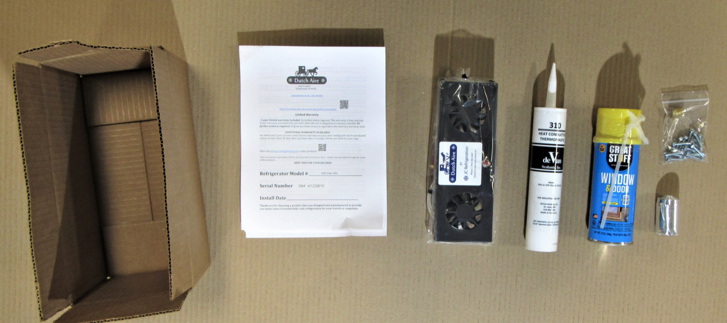 Begin by covering up your floor with blankets and removing any door handles or smoke alarms that might hinder the exit of your refrigerator from your cabinet. Turn off the water pump (if you have an ice maker in your fridge) and the refrigerator control panel.

: WARNING:
Make sure to turn off LP gas at the tank before starting the install.

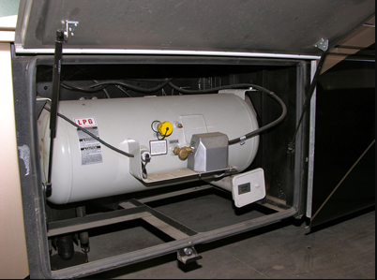

Locate your refrigerator side vent on the outside of your RV. Good idea to take a pic of these wires or label them so you know which goes where when done.Take the main 12V wires (RA) loose from your board. The wire colors will vary from coach to coach, and there is an old style or new style as seen.
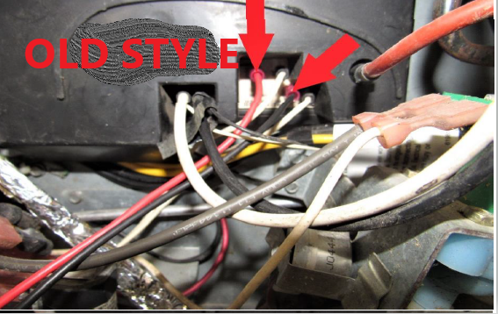N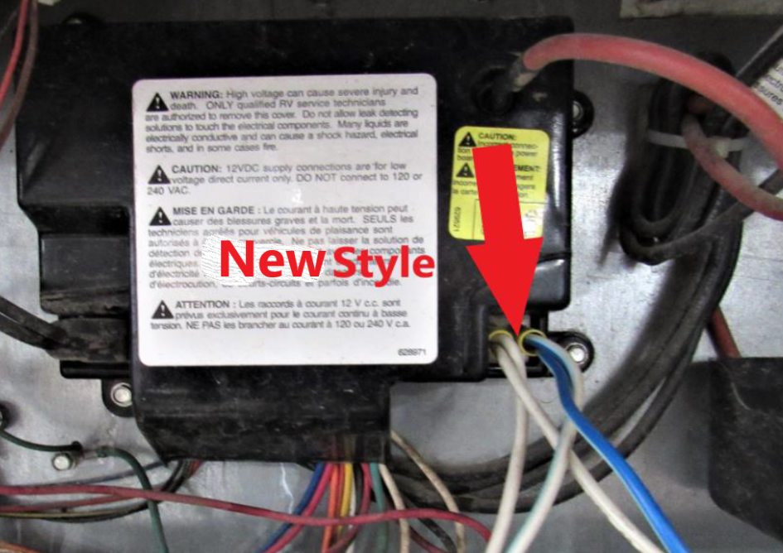 Note: If your wire ends are not insulated, wrap the end in electrical tape on positive so you don’t blow the fuse.
Unplug your 120v plug (RA) from your RV receptacle.
Take the LP line (YA) off of the LP solenoid valve. Make sure gas is turned off (see step one)

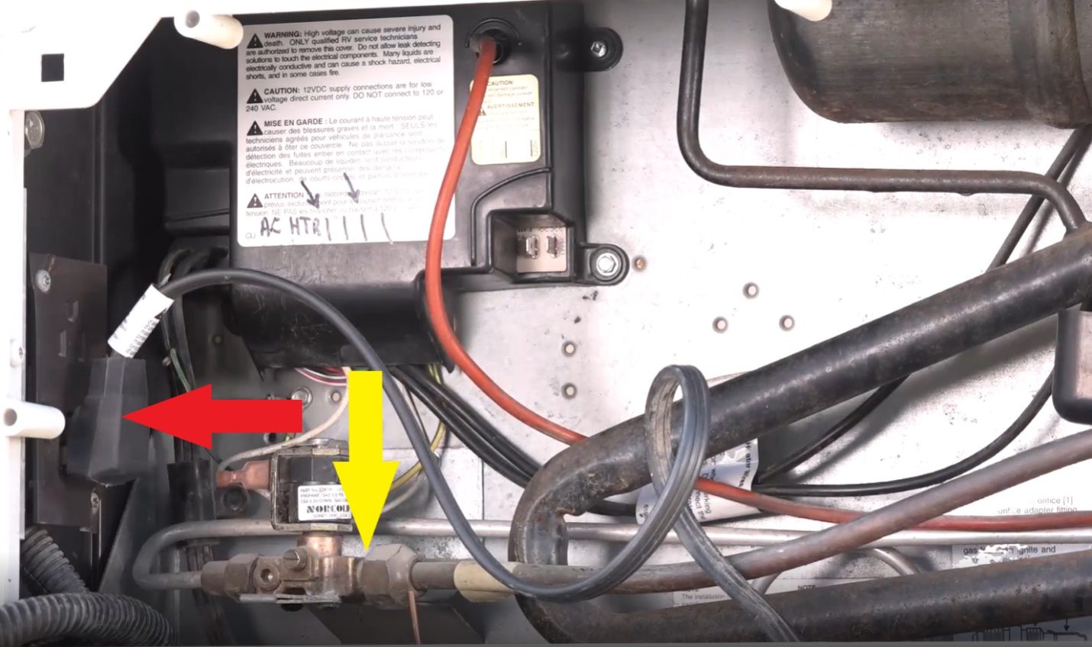

There are many different styles out there but most have at least 2 mounting screws through the back plate holding the fridge to your RV floor. Screw size and bit needed will vary from coach to coach.
Remove these screws or Bolts (RA).
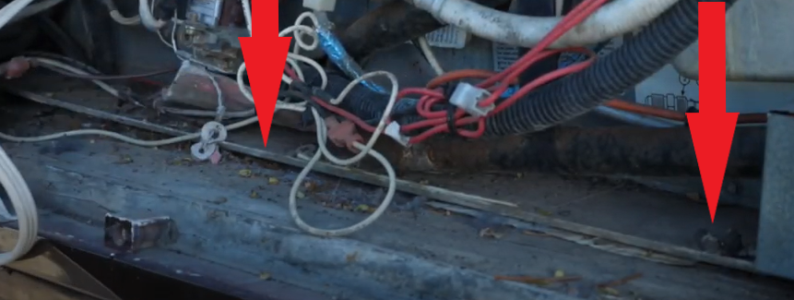
On Winnabago coachs you will have 4 bolts lagged to a steel side plate, 2 on each side of the fridge, also the top roof vent cap needs to be removed and 2 to 4 philips screws need to be loosend from the top of the fridge.
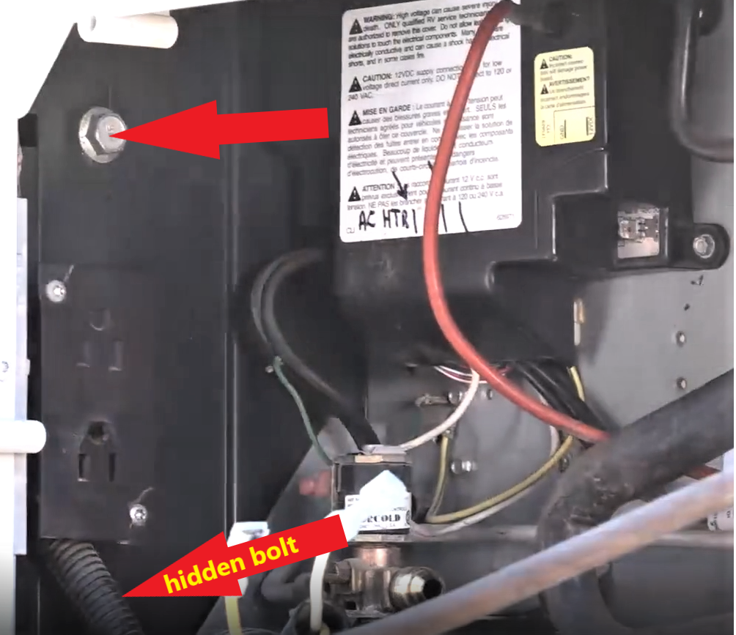
Going inside again start by removing the black trim covers on the top and bottom.
Remove the two mounting screws on top and bottom (RA). Screw size and bit needed will vary from coach to coach.

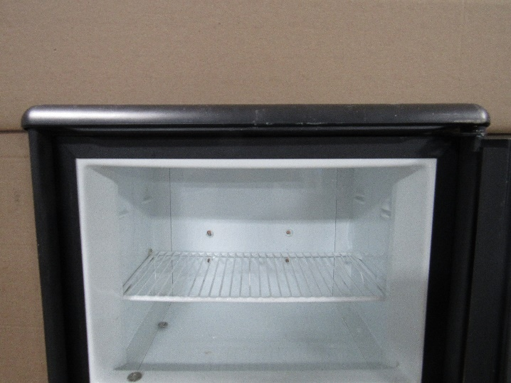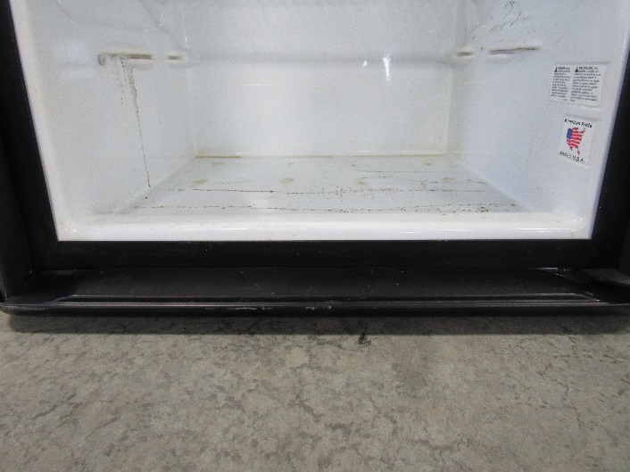

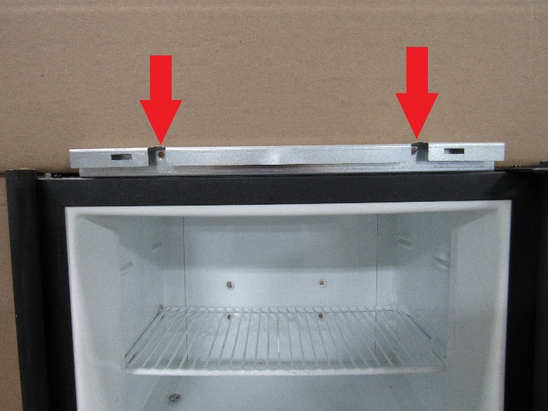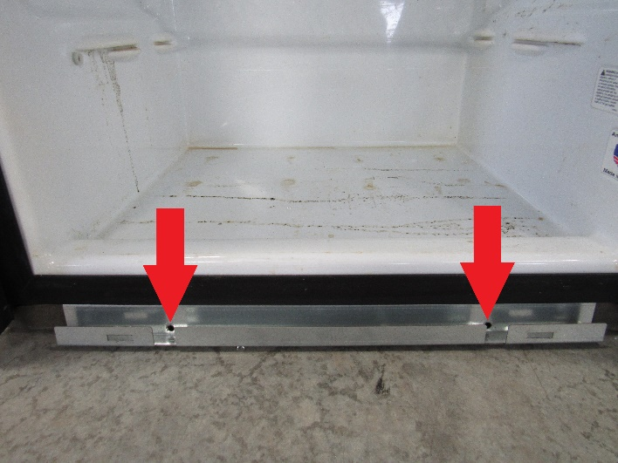

Take a 5/16” hex bit and cordless impact driver and proceed to loosen all the screws (RA) in the freezer and the refrigerator. Unclip thermistor and leave it hanging down into the fridge box. Removing your freezer shelve or top fridge shelve is optional.
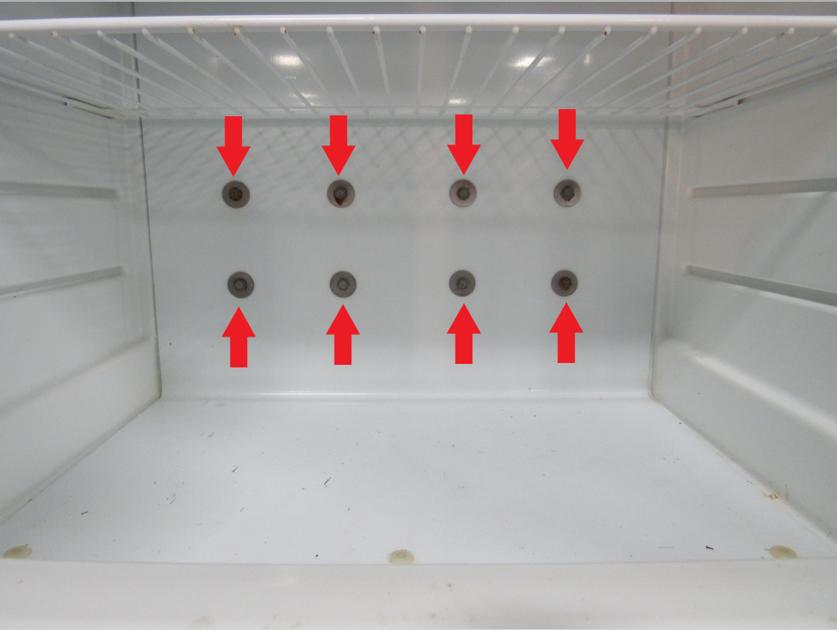
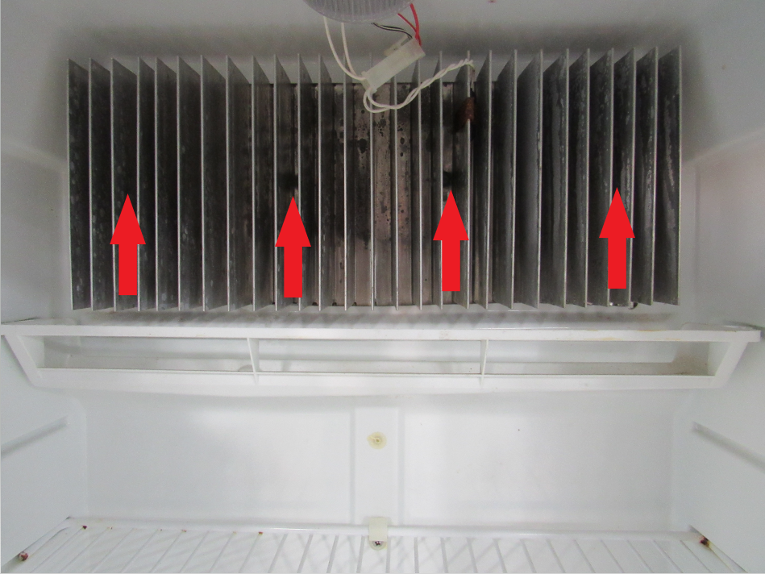
We do not show the fridge being slid out onto the floor, as the lay out of the coaches vary greatly and so it could be misleading to your scenario. But the object is to have 1 guy on each side of the fridge and as your fridge starts to exit lift up gently so when the rear end of the fridge fully exits the cavity that it does not drop, but needs to be gently and carefully set on the floor and pushed or carried to your open floor area. Lay fridge face down on the floor, making sure doors are latched shut so they don’t swing open and we normally put a pile of blankets on the floor by the top freezer door so the fridge is lying face down on an angle.
Take out mounting screw (RA) on top, Placement can vary
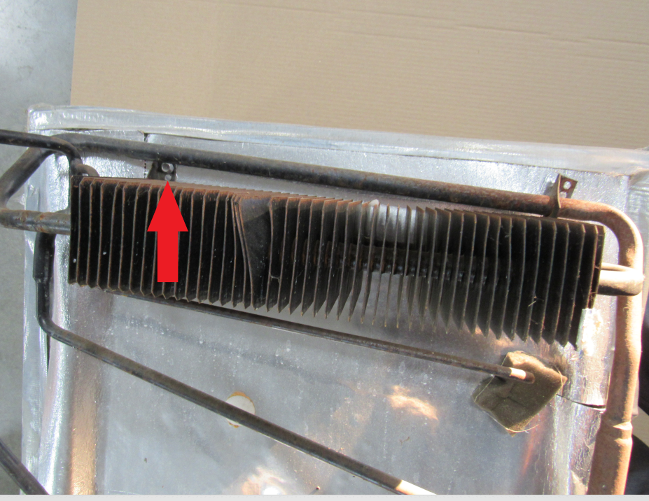
Remove bottom 2 mounting screws, may vary in location (RA).
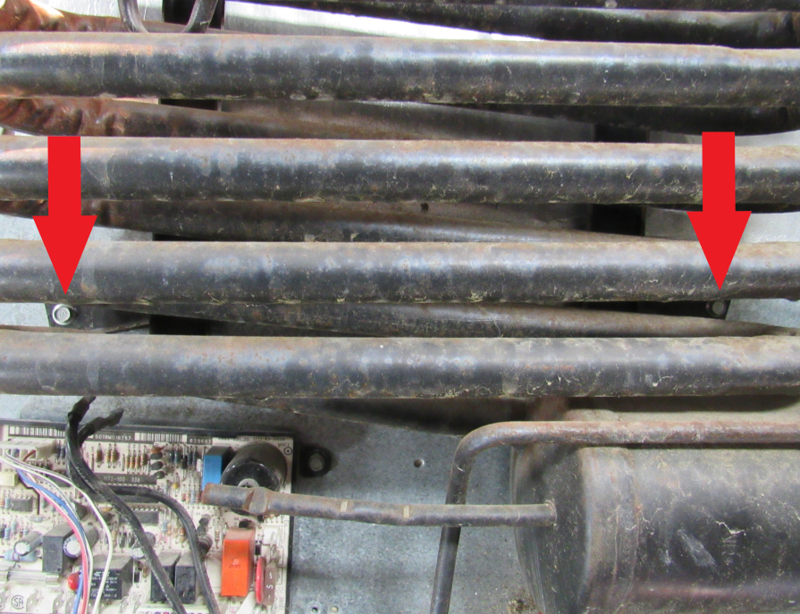
Take off the 2 white LP valve wires (RA).
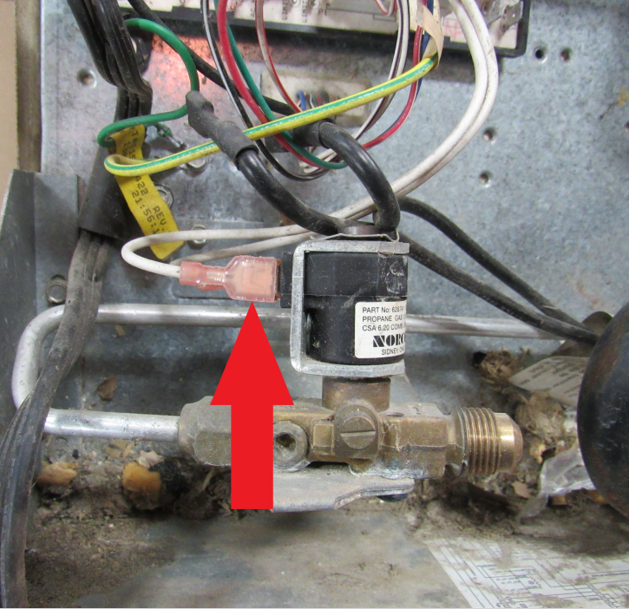
Unclip the igniter wire (RA) from the board.
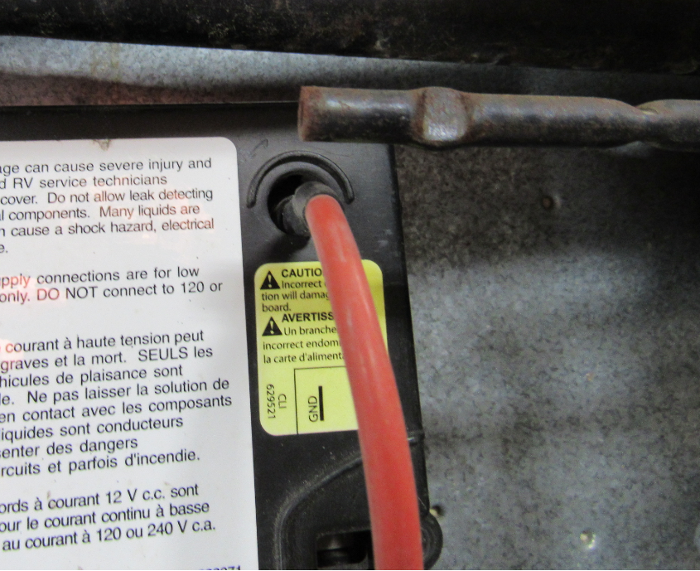

Take the 120v plug (YA) loose from the board in order to remove the cover.
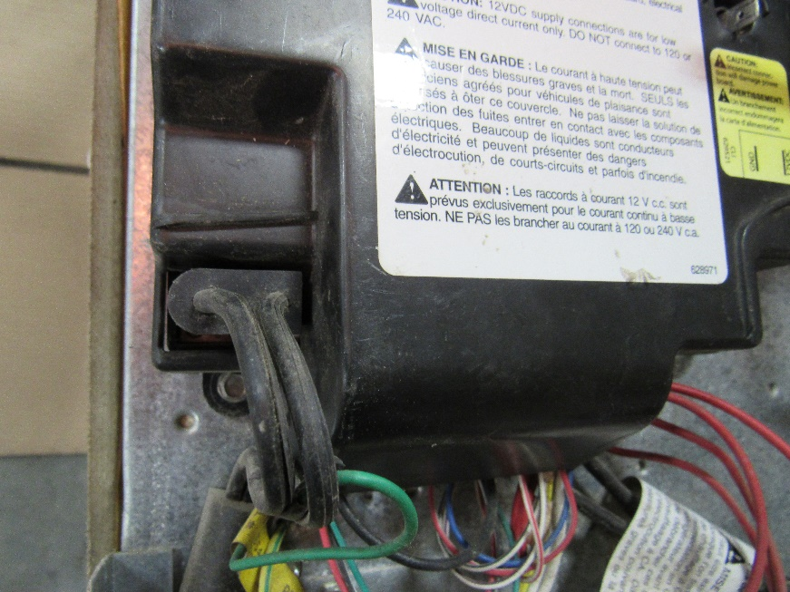
Remove the board cover and then remove the heating element wires. (RA)
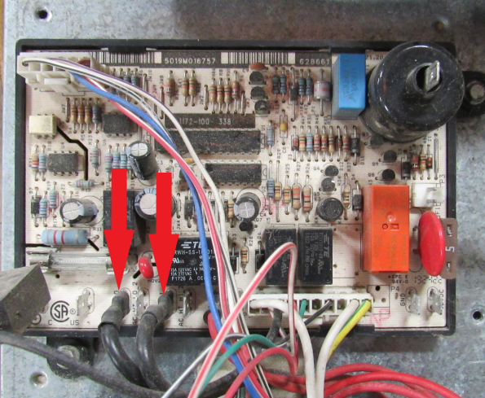

Remove the 120V power cord completely as it will no longer be needed. Also, remove the green board ground wire.
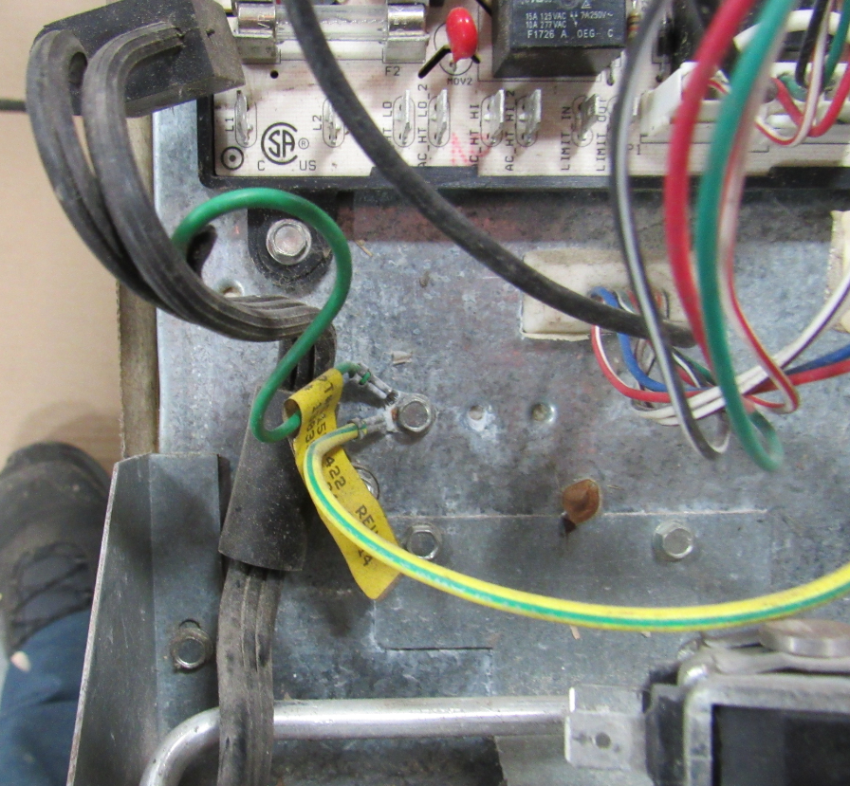
Also remove the gas valve mounting screws, and the defrost cup.
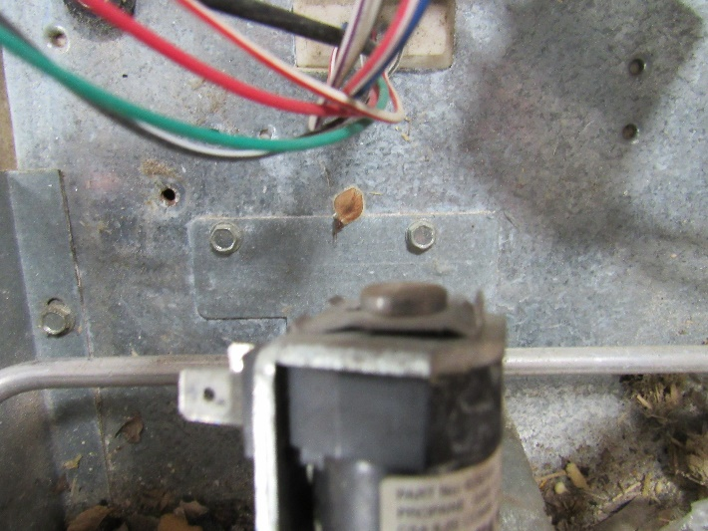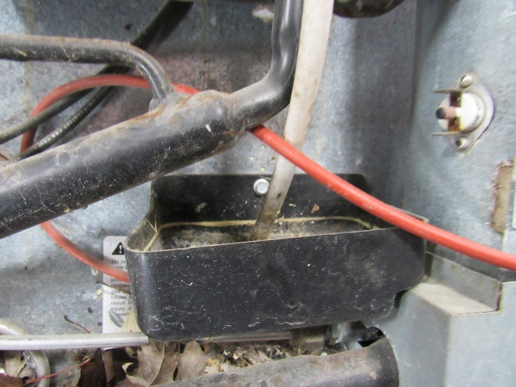

Take unit off the back of your refrigerator by lifting straight up and out. Clean off any residual foam or thermal sealant around the edges (RA).
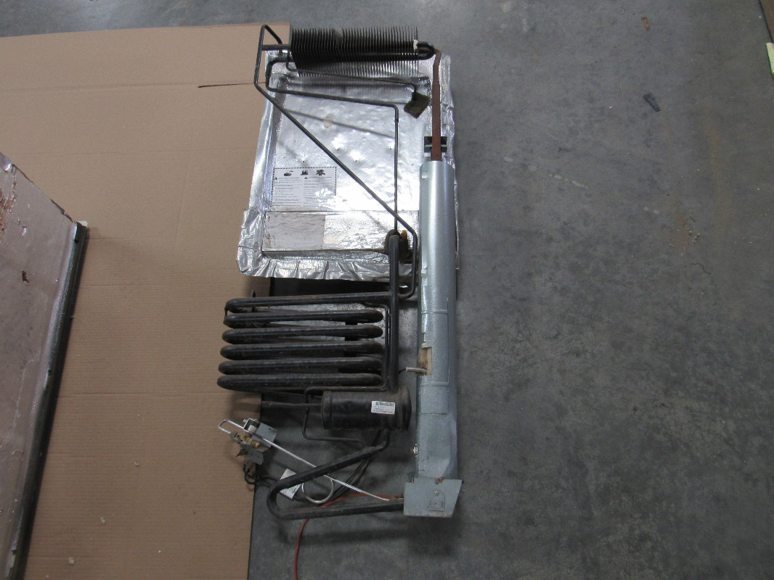
Clean off the old thermal mastic (RA) from the freezer section and the fin section. A large blade putty knife or scraper works well.
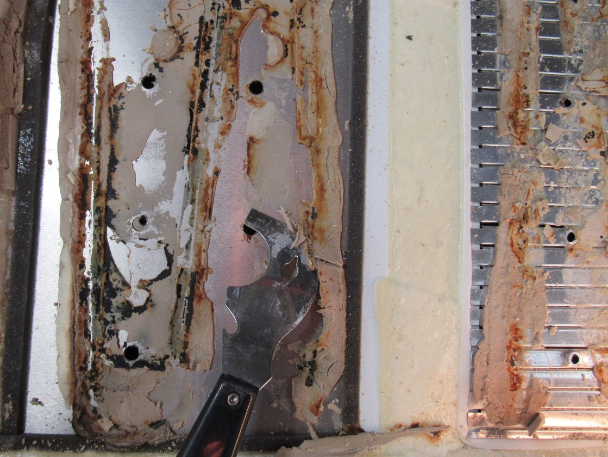
Take the fin fan out of the plastic bag. It will include two scotch locks that we will use to hookup later.
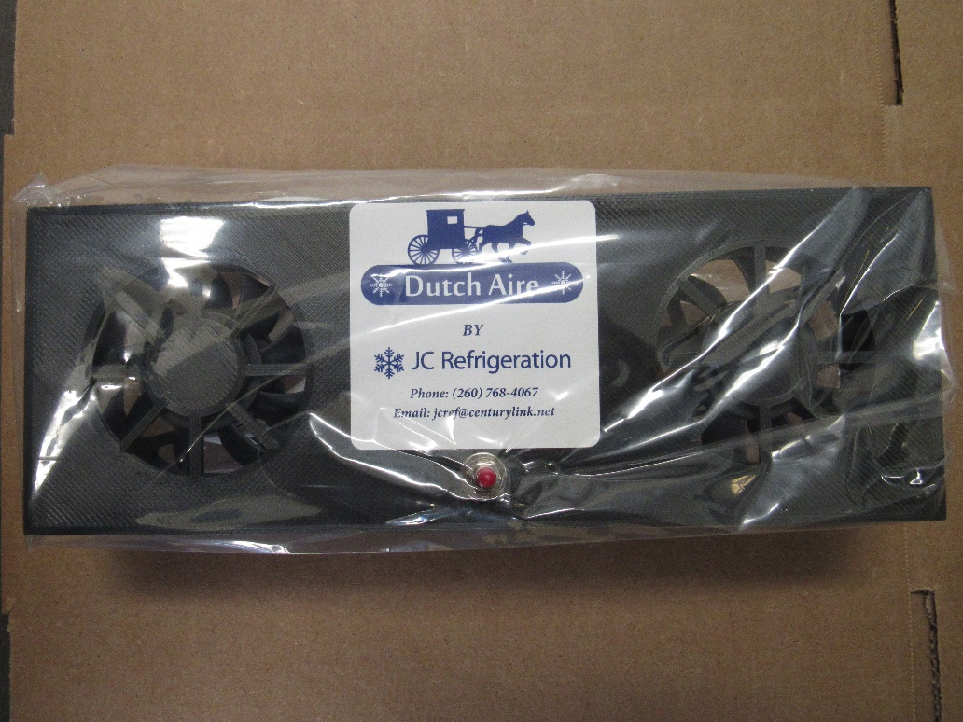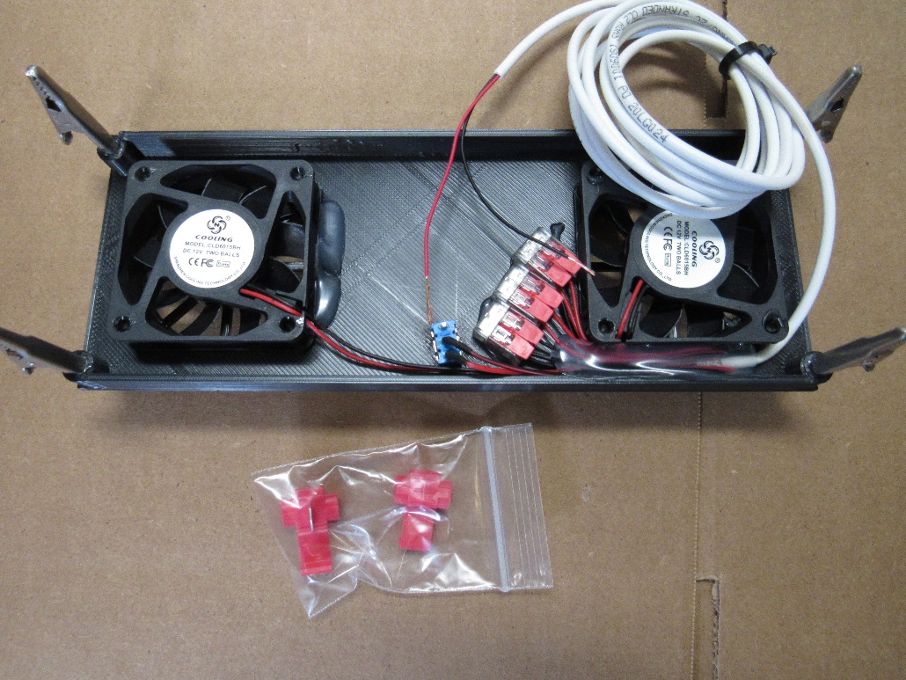

Installing the fin has 2 options:
Option#1 Set the fin fan into the refrigerator fin opening, make sure it’s somewhat secured to a shelve for now. Leave enough wire as shown inside and also enough on the bottom to hook up with later. The fin fan wire will remain in this position throughout the rest of the install.
Option #2 If you would rather install the fin fan wire thru the defrost hose, please see our fin fan installation manual at: https://jc-refrigeration.com/wp-content/uploads/2021/04/fin-fan-installation-website.pdf?3f35fa&3f35fa
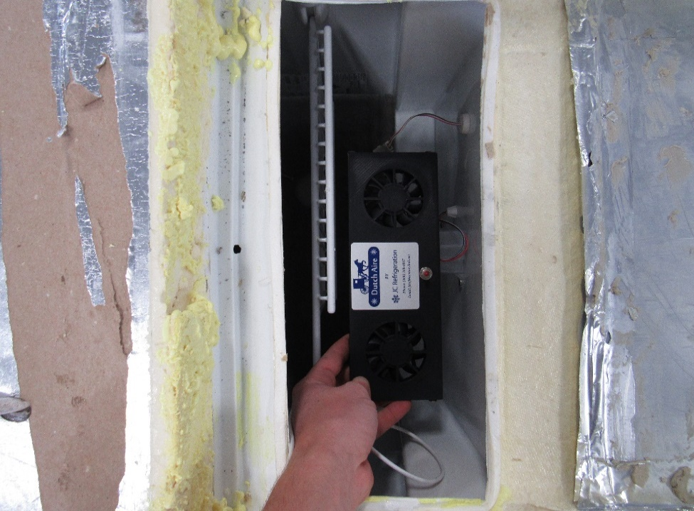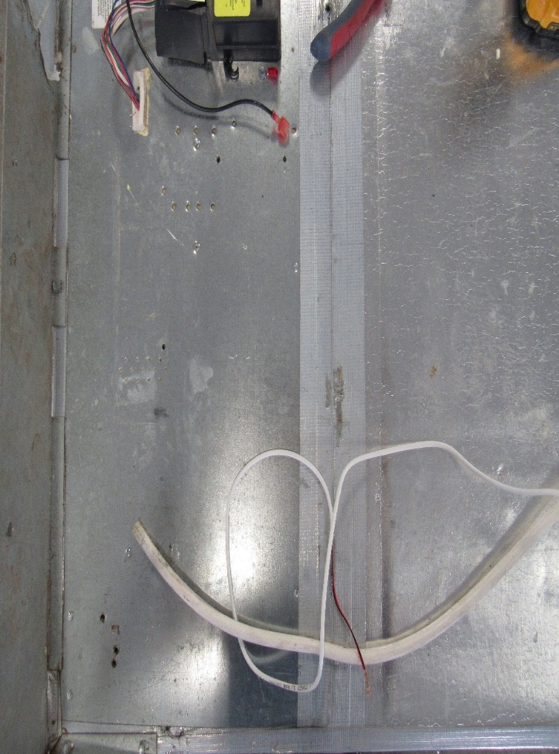
Warning: The next few steps are very important. If done incorrectly, the cooling unit freezer and fin screws might not line up the best. If possible, have someone to help you with the next steps as it will make everything much easier.
First, we will do a “dry run”. Set the unit in the box as shown in picture.
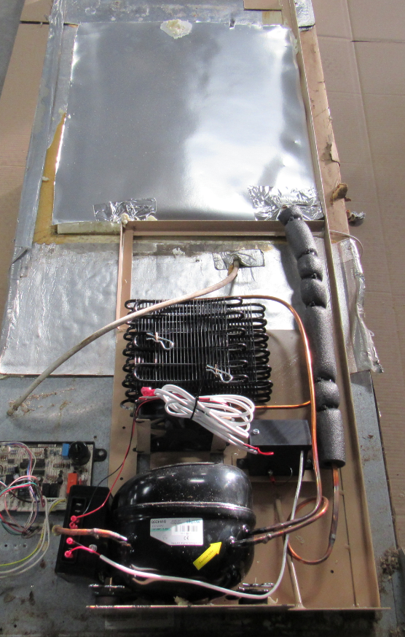

If you are alone, screw two self-drilling 5/16’’ mounting screws (RA) that are included in the parts bag. Your exterior mounting holes will not line up to the original holes. This will hold the unit in place for the next step. If you have another person with you leave these screws out and have the second person hold the unit while you set the refrigerator upright into the standing position now open freezer door and make sure mounting holes in the freezer are aligned with the cooling unit holes.
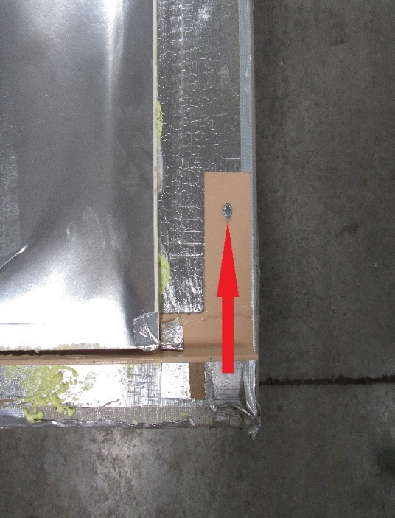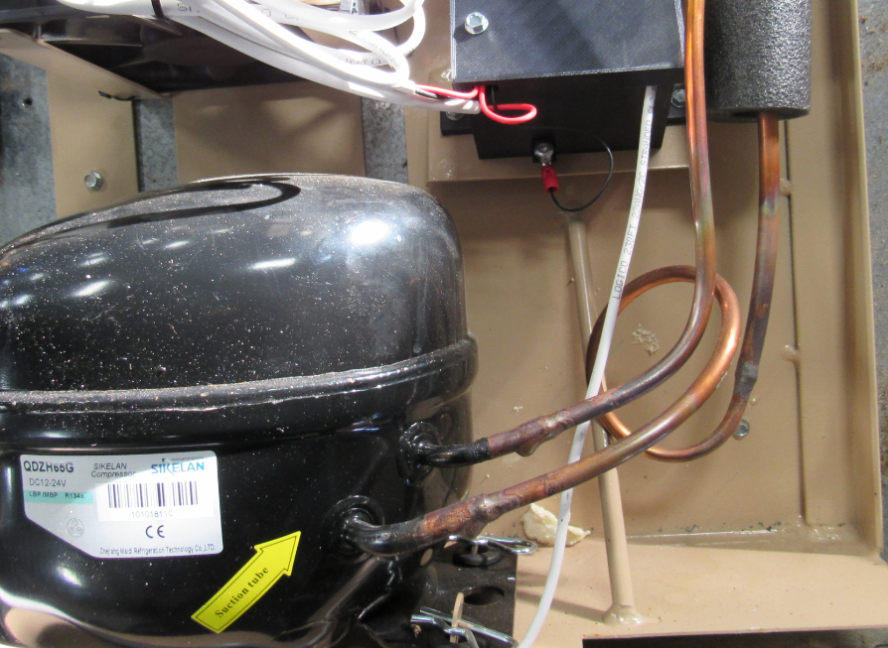
If holes are not aligned have the rear person lift the unit up or down or side to side till holes are aligned, or if alone you have to set fridge back down, take out mounting screws and adjust the unit to where the holes line up. It does not have to be perfect, just close enough where you can see the edge of the screws. Don’t be afraid to sand or shave foam off the side, top or bottom to let the unit slide the way it needs to go to line up the freezer screws. Pictured below is an example with the holes just visible on the bottom corner (RA)

Warning: Your box holes can be redrilled or enlarged to make holes line up and then the washers can cover the hole, (YA) but do not ever drill new holes into the cooling unit plates as you will hit the cooling tubes causing a rupture. If part of holes are visible you can either leave them as is since unit will be sealed in the back or you can use white silicone caulk to cover the holes.
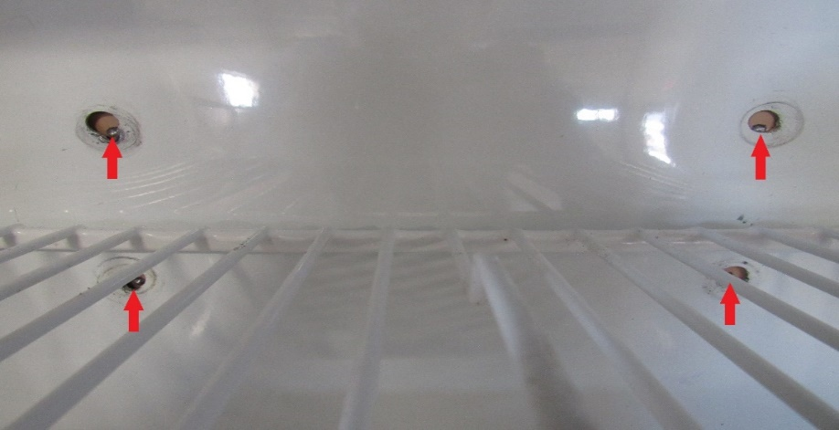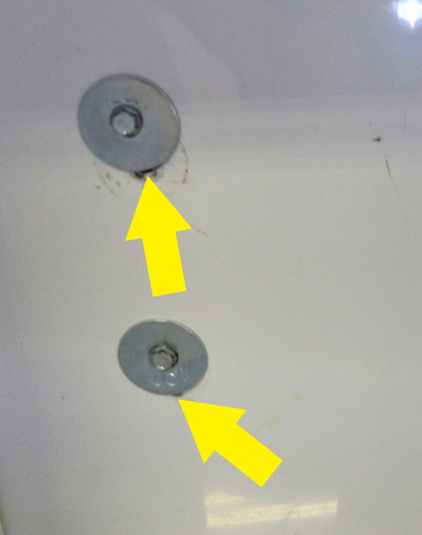

Once you have positioned the unit to where your holes align with your freezer holes, re-enter the previous mounting screws plus (2) 5/16’’ screws shown in picture below (RA). This way you know exactly where the unit needs to be later. If a second person is there to help these screws do not have to be put back in.
Take the unit completely off the box again. We will install the thermal mastic next. Take a caulk gun and place a small bead in this fashion. You will need to use the whole tube.
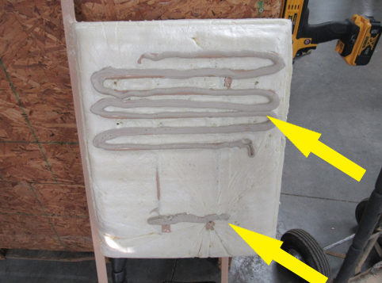
Lay unit back into box being careful so as not to scrape off any thermal mastic on the box, and make sure unit is in position where you had it last so freezer holes line up. Now screw the unit to the back of the fridge using the 5/16” self-drilling hex screws provided

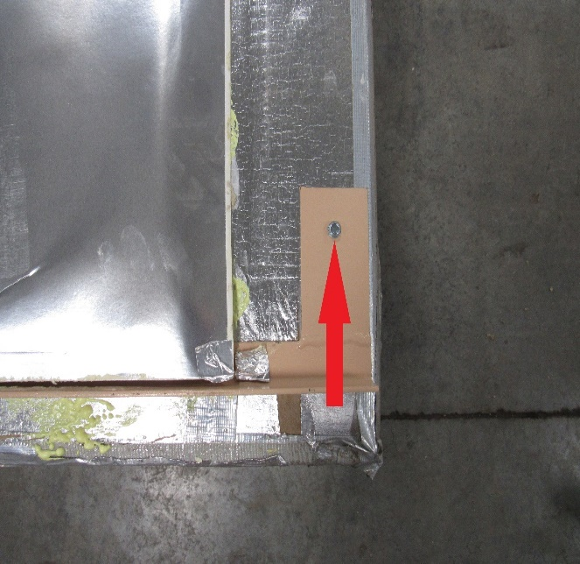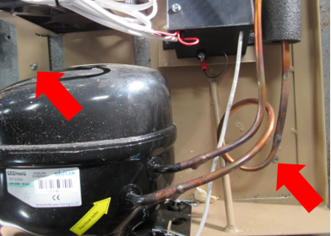
Your fin fan wire will exit on the bottom of the foam insert between unit and box. (YA)
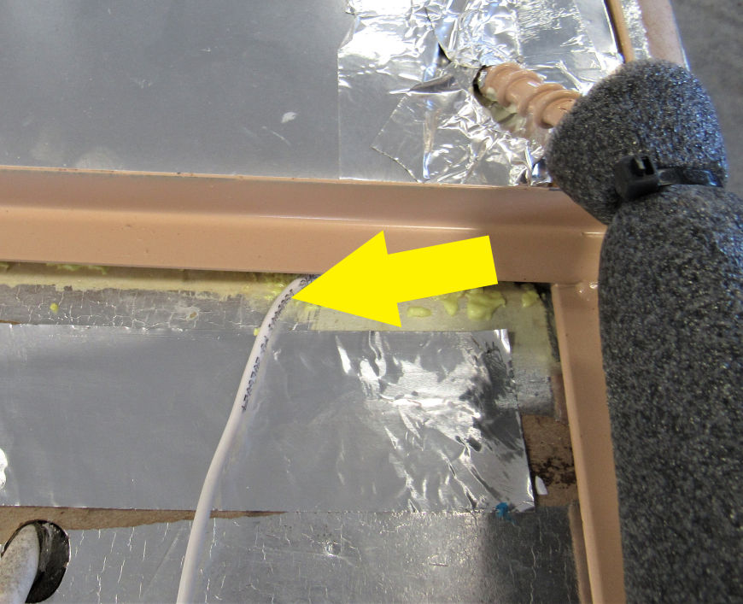

Set the refrigerator upright into the standing position and install all 8 freezer screws, using the supplied 1 ¼” HEX screws in the parts bag, pulling the unit tight against the back.
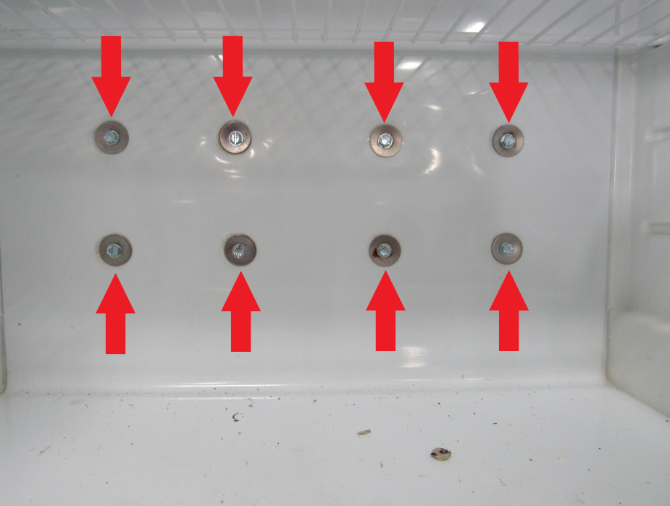
The fins in the fridge will now only have the 2 middle screws attached instead of 4 like the original had.
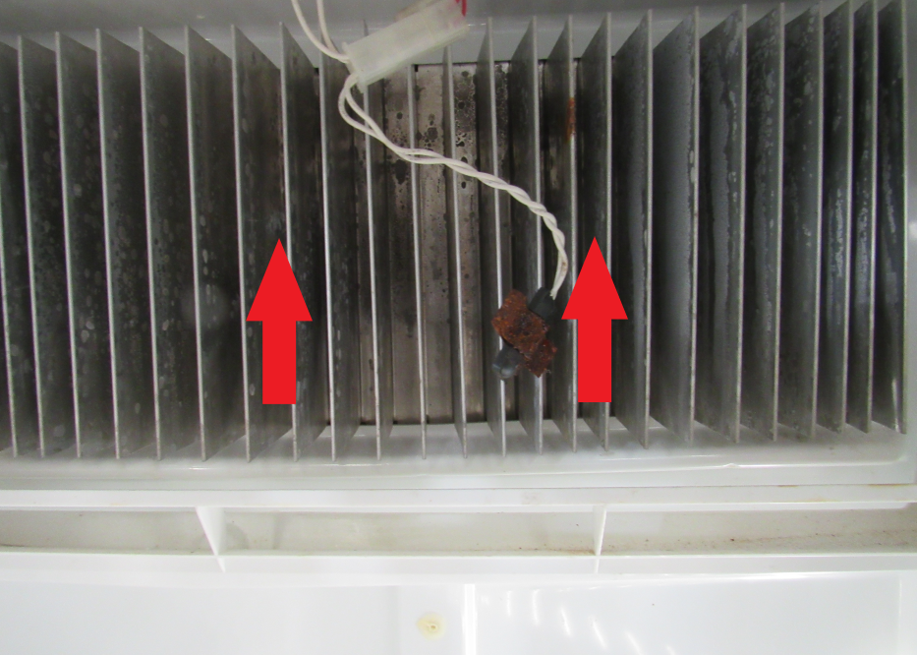
Now reattach the thermistor and also clip the fin fan on to the fins.
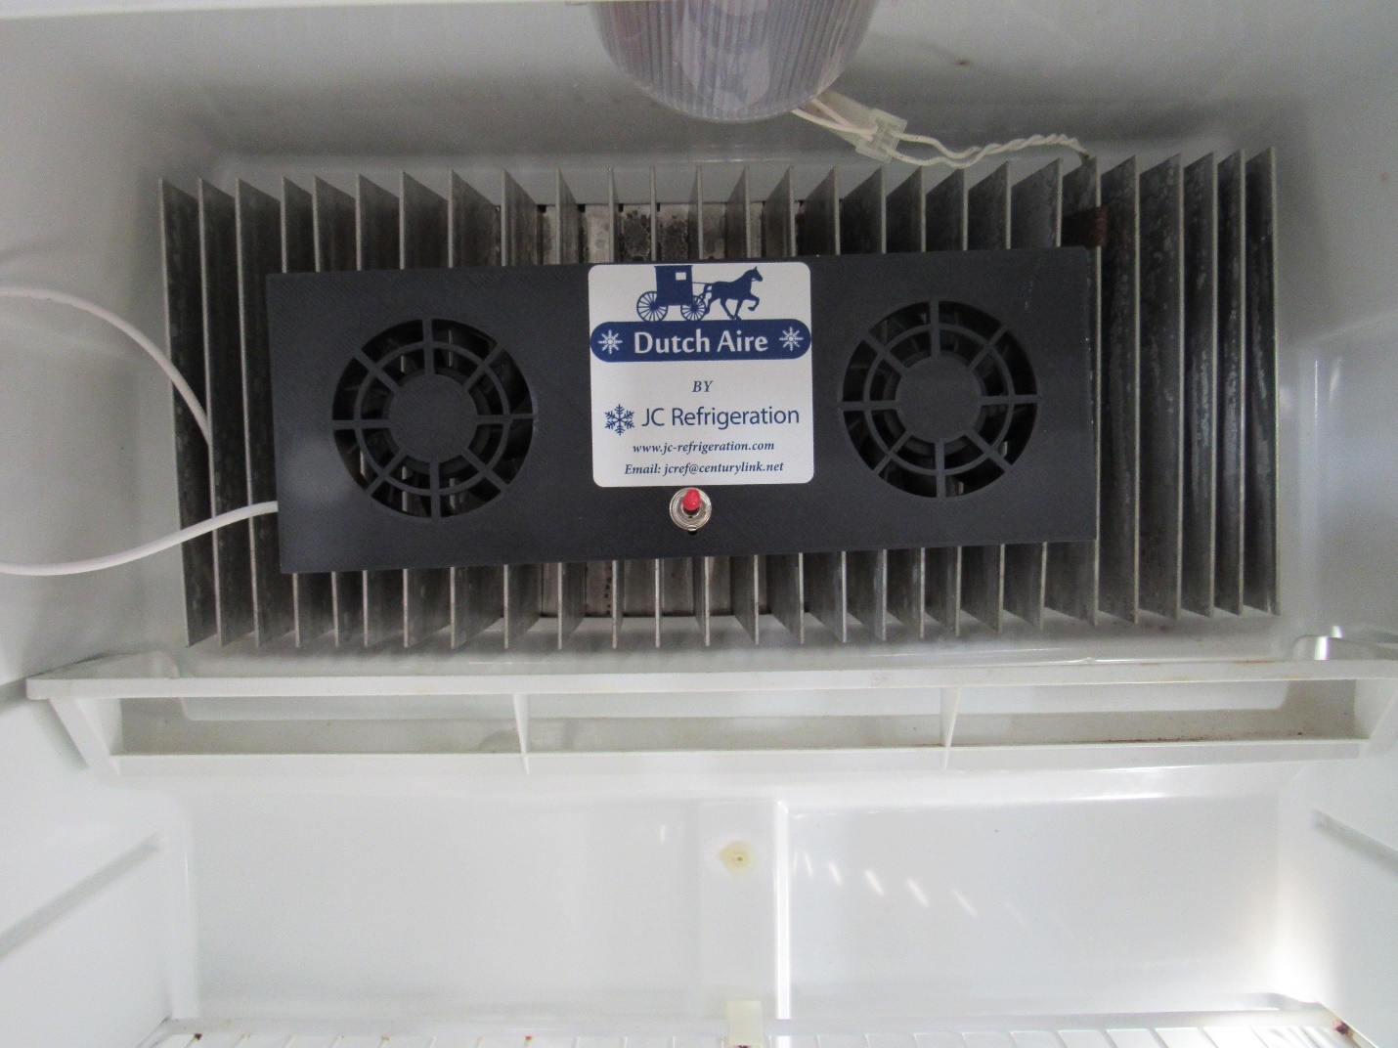

Warning: Make sure this step gets followed precisely, otherwise your fridge is unable to cool properly
Lay fridge back down, take the can of Great Stuff foam (shake can for a few seconds) and apply a bead of foam around all four sides as shown below. Make sure and seal all cracks and gaps. This will help seal all air leaks while travelling down the road.
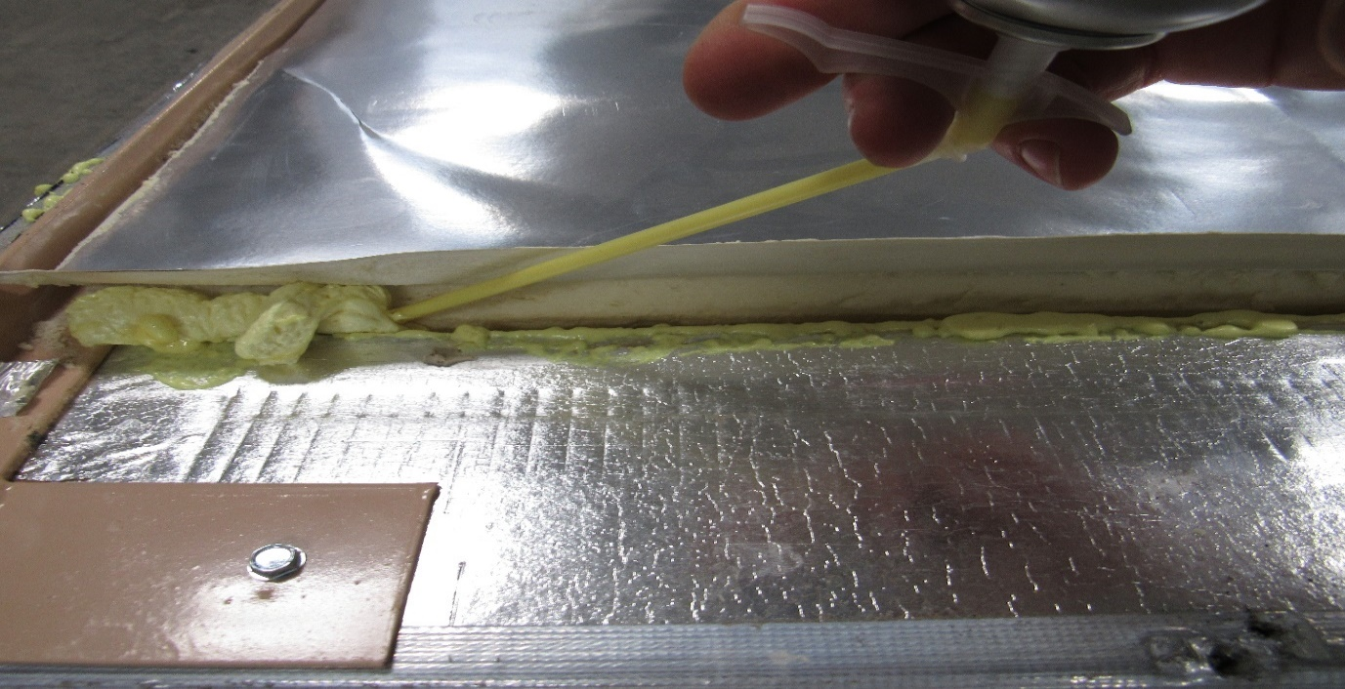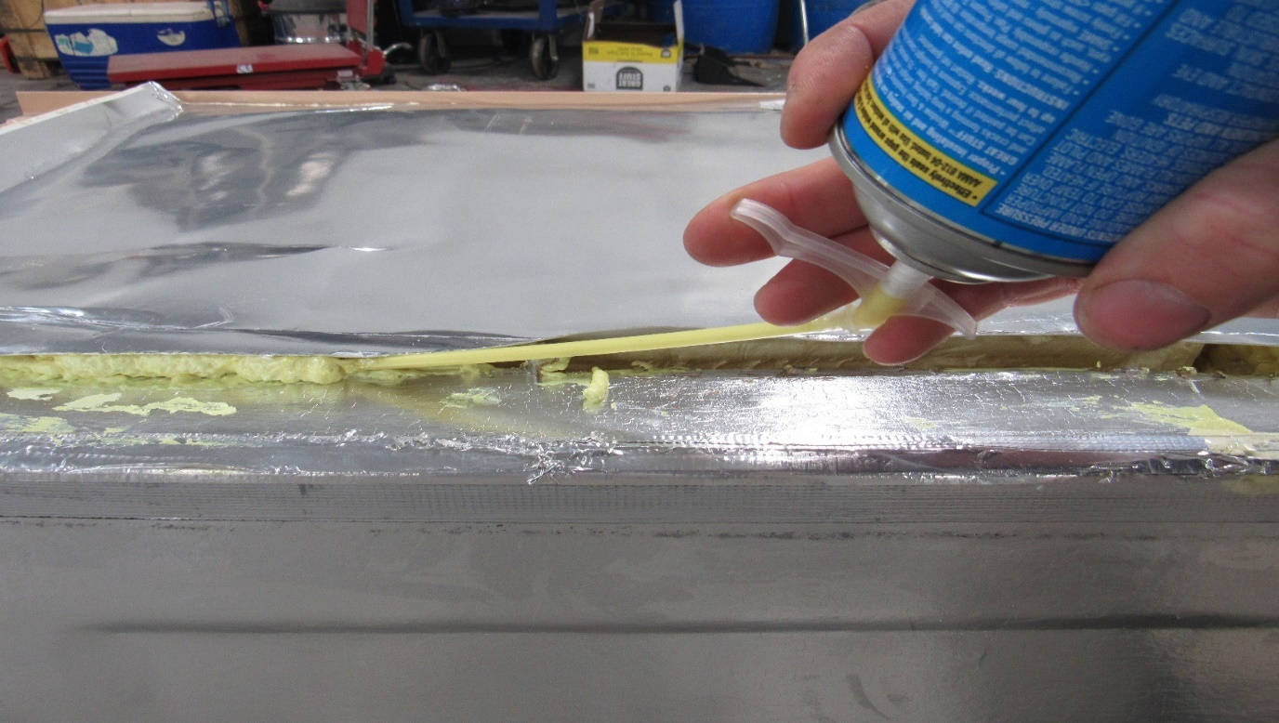
On areas where the steel frame is tight against the box, take a small pry bar or flat bar and lift up enough to get in there to fill up the gap between unit and fridge box. 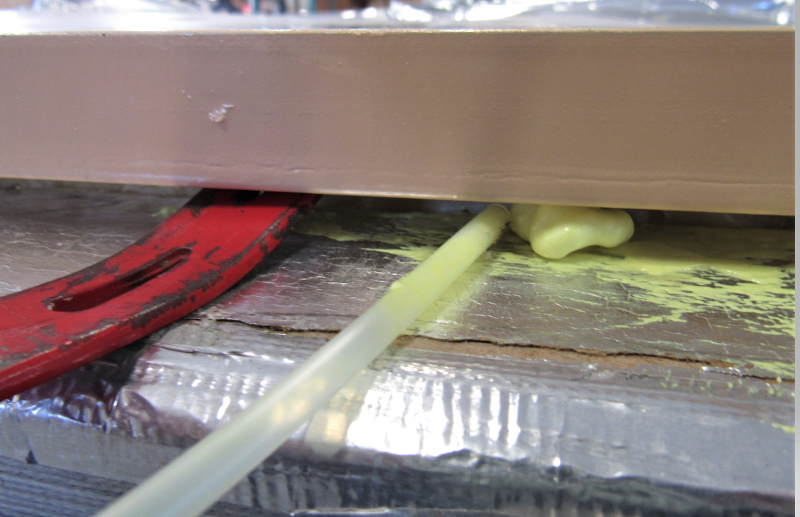After filling all gaps with foam, follow up with the supplied aluminum tape as shown. This is for cosmetic looks only; this tape does not help seal.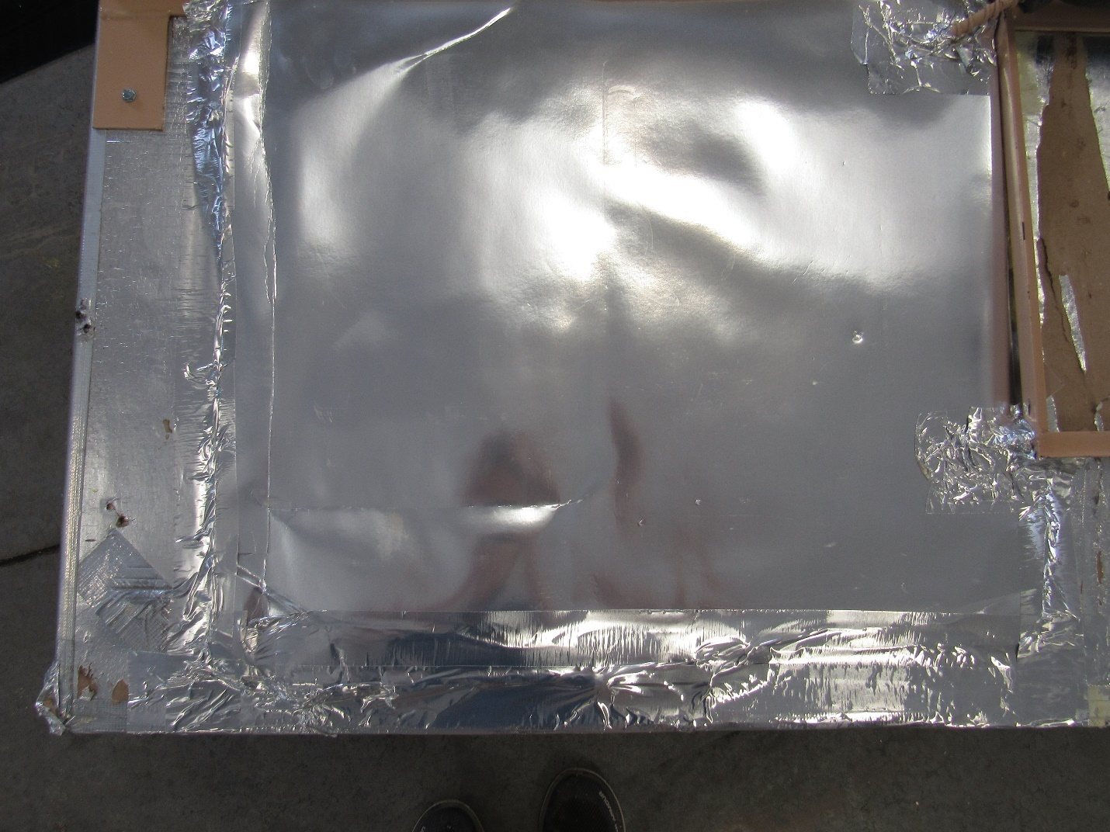
On the New Style board connect the “limit in” spade and the “limit out spade together using a short wire (any gauge) completing the circuit. This is where your safety temp switch was plugged into, you will no longer need it.
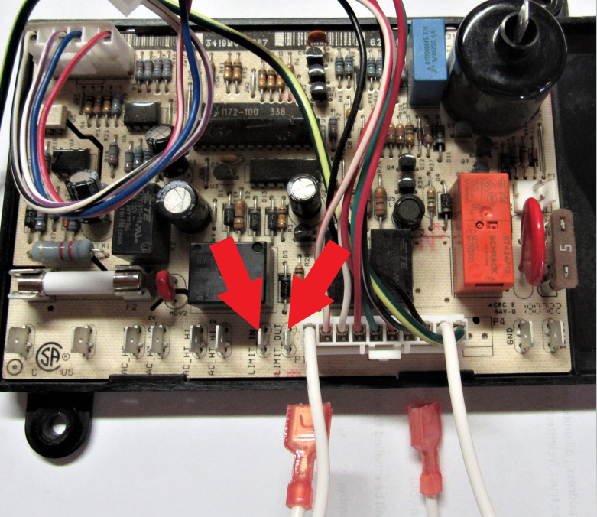
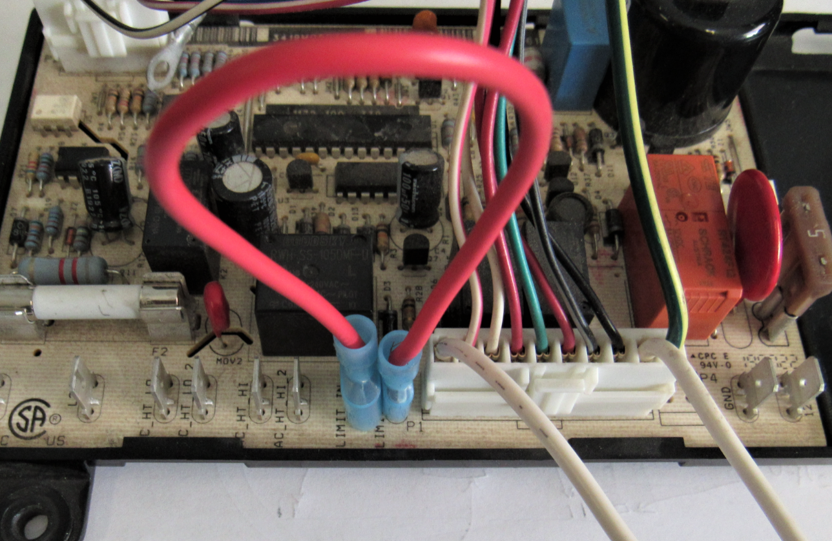
Reinstall board cover using self-drilling ¼” screws supplied,
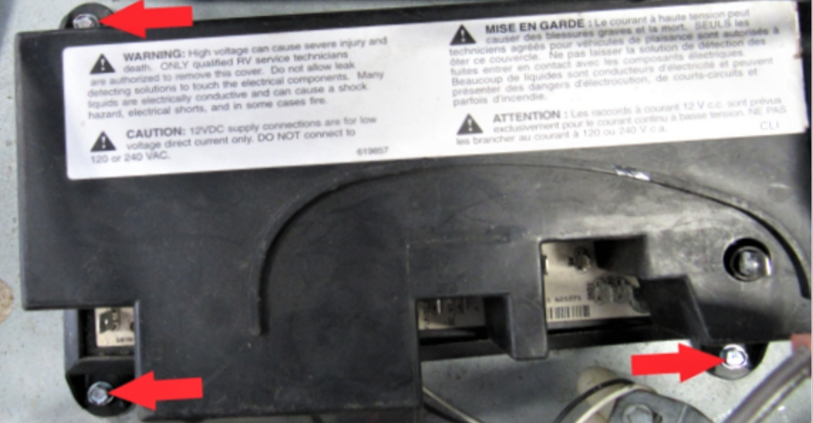
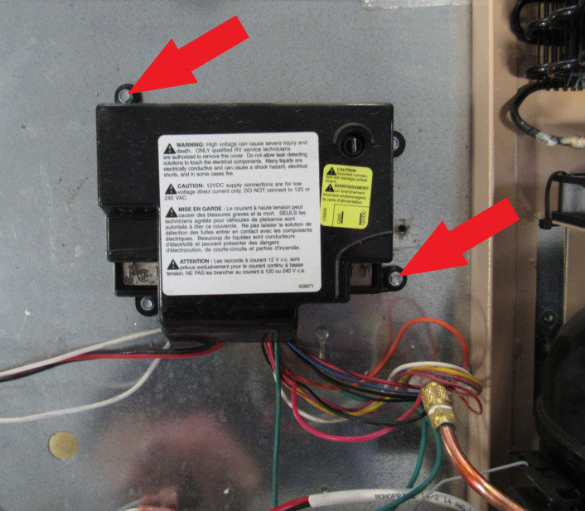

Snip the zip tie which holds the wiring that came with the unit.
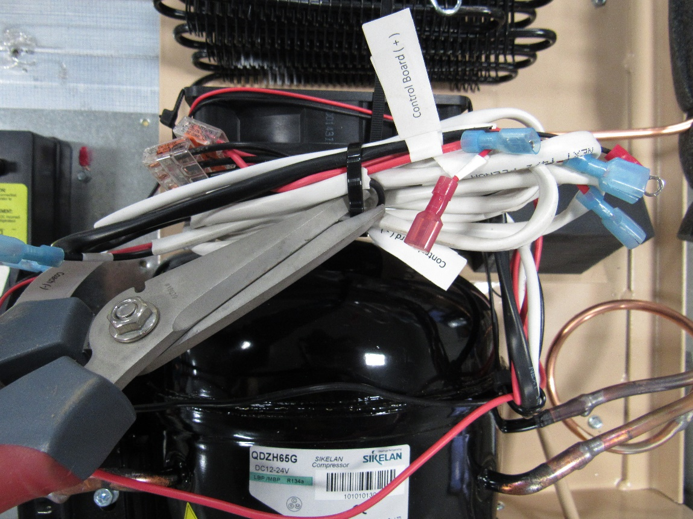
You will have 3 main wires coming from the control box that need to be hooked up. They have tabs on where they need to go. 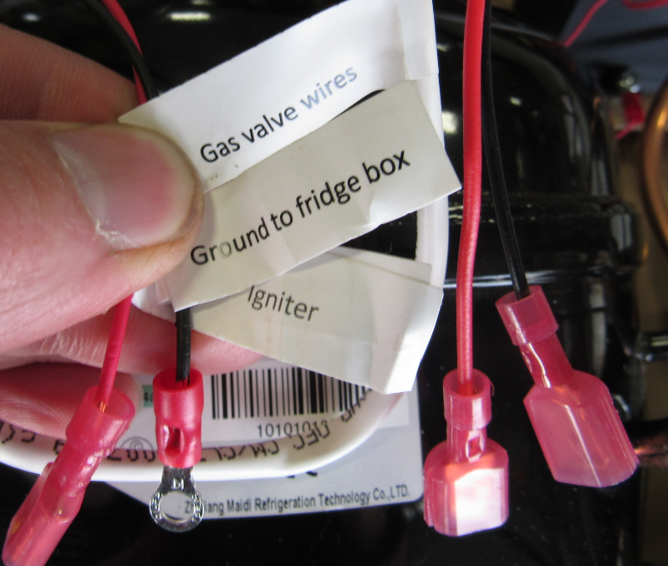
On Old Style board, take the two white wires that were removed prior (RA) coming from the main control board, and these need to be plugged into the wires labeled “Gas valve wires”. These 2 white wires used to go to the gas safety valve on the old unit (Female Ends). Our controller gas valve wires have male ends (YA). Reattach vent fan wires (BA) black on right white on left.
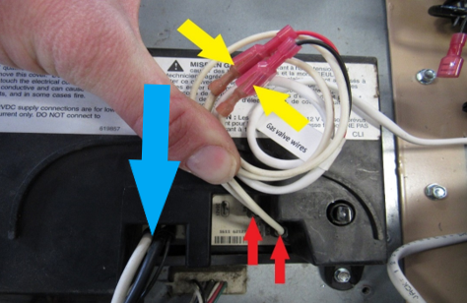
On New Style board take the 2 white wires (RA) and connect to the 2 gas valve wires. You won’t need to take off the board cover, this picture is just for reference on where the white wires come from.
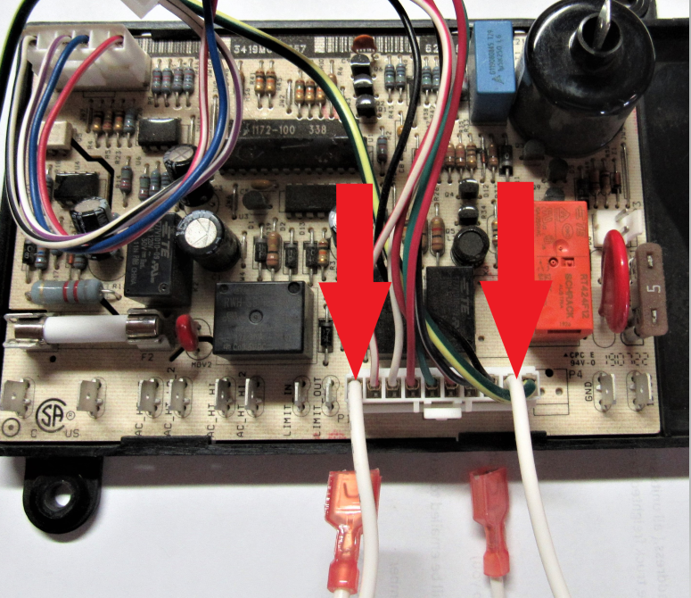
Take the wire marked “Ground to fridge box” and “Igniter” and place them as shown. Igniter simply plugs into the igniter terminal (RA) on the main control board and the black wire ground terminal gets grounded out to the box (YA). 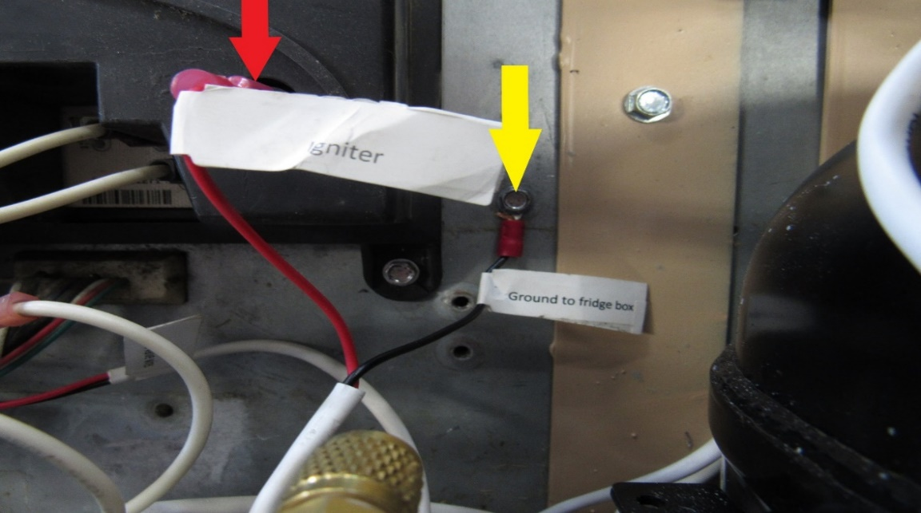
The two white gas valve wires (RA) coming from the main control board need to be plugged into the wire marked “Gas valve wire” does not matter which wire goes to which
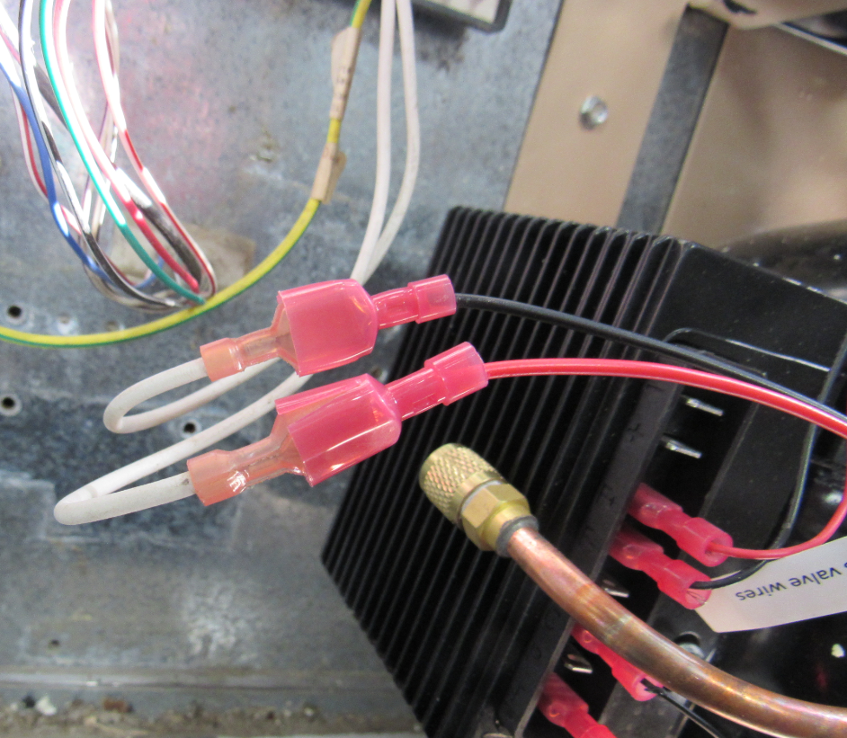
Find the 3-way splitter included with the cooling unit. The “Compressor Red +” and “Compressor Black -” will most likely already be plugged in to the compressor. If they are not, the black wire goes to the top spade and the red goes to the second spade from the top down.
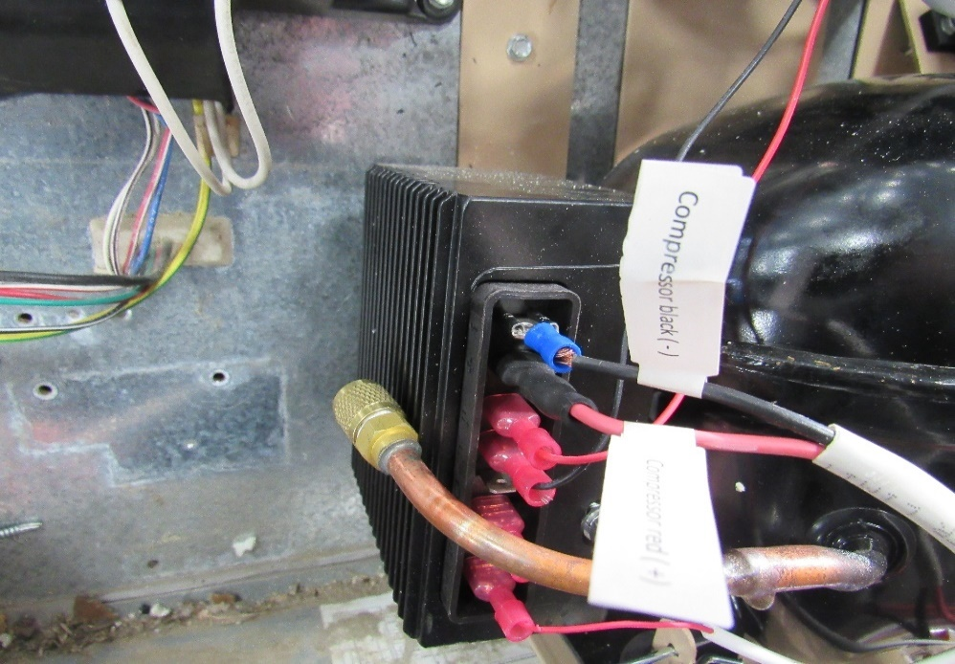
The wires marked “Control Board +”, which goes to spade marked 12VDC, and “Control Board -”, which gets plugged in to spade marked GND, will get plugged in to the control board after the cover is attached. This pic is the new style so see page #5 for old style placement.
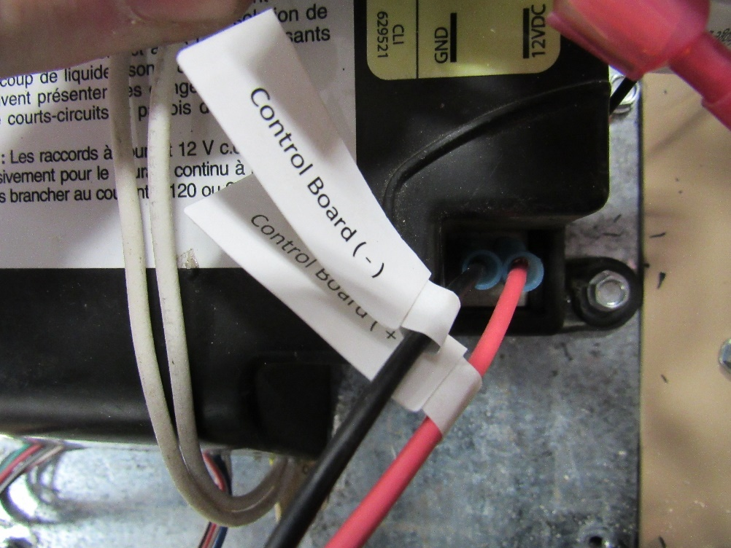
The wires labeled “Coach +” and “Coach -” will get plugged in to the 12V wires that are coming from your batteries. So set those aside for now as they will need to be plugged in once the fridge is back in the cabinet.
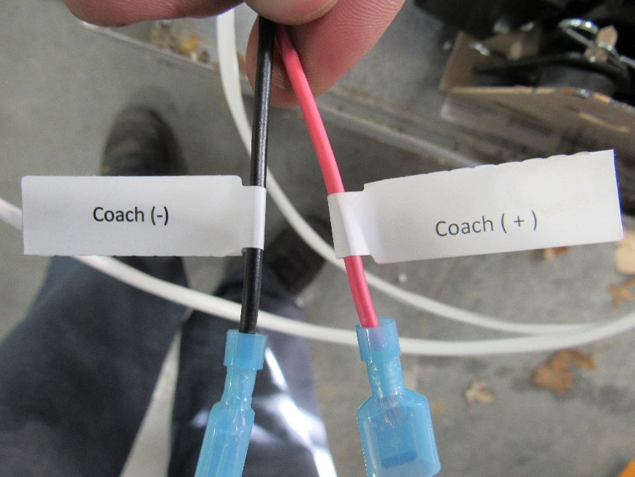
Install the board cover,plug in the igniter and the “Control Board + & -” and bundle loose wires together and attach zip ties to all loose wires.
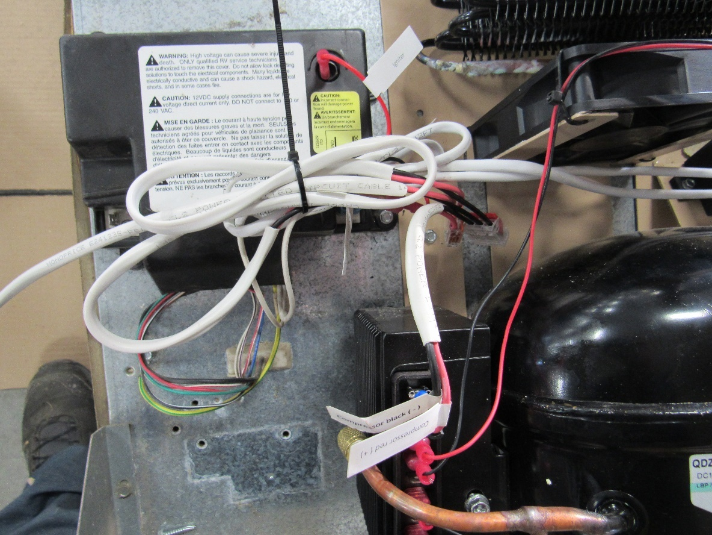

Also attach the green ground wire for the control board back to the back of the fridge box.
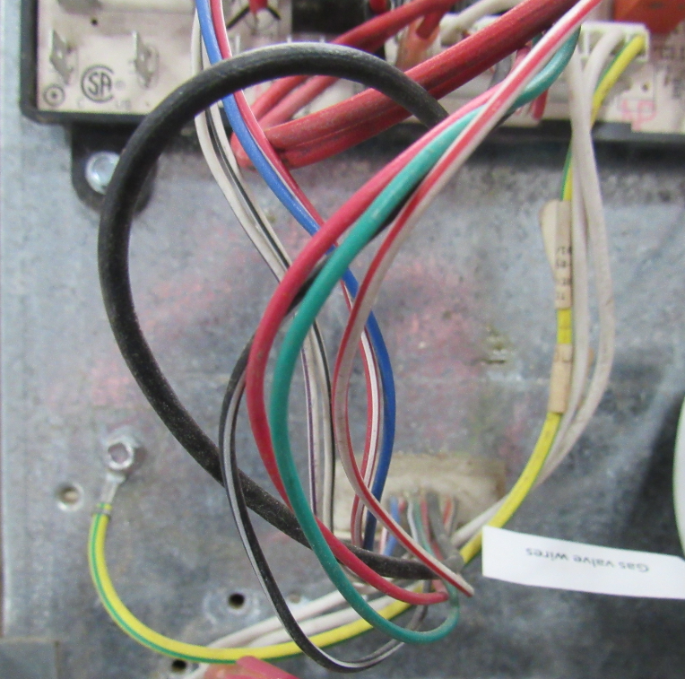
Slide defrost cup (RA)back under copper tube and attach with one of the 1 ¼ ” self drilling screws or this defrost cup can be left off and the hose stuck out the side vent when all done.
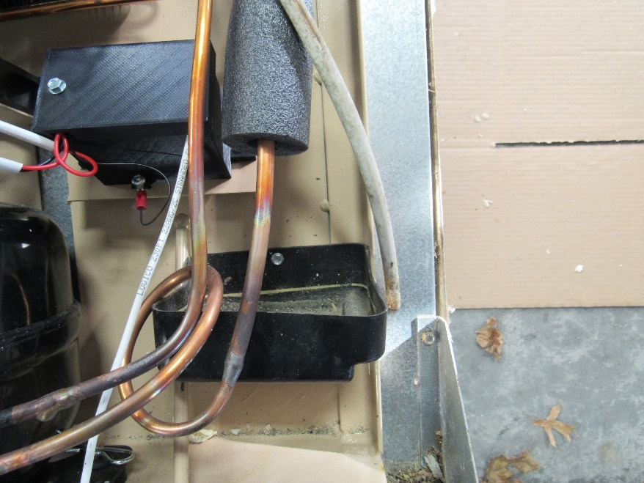
Warning: Please make sure and follow this thru this step, otherwise unit could over heat causing damage to the unit.
Before installing the fridge back into the cavity, check to make sure wall insulation is secured and this is a good time to sweep or vacuum any loose debris. If this fridge is installed into a slide out then make sure and remove the top side vent (YA) baffling (RA), as you will no longer need this and all it will do is slow air flow. If Its installed into a roof vent style then nothing has to be changed, but make sure and leave both vents open, as this unit will still have to breathe
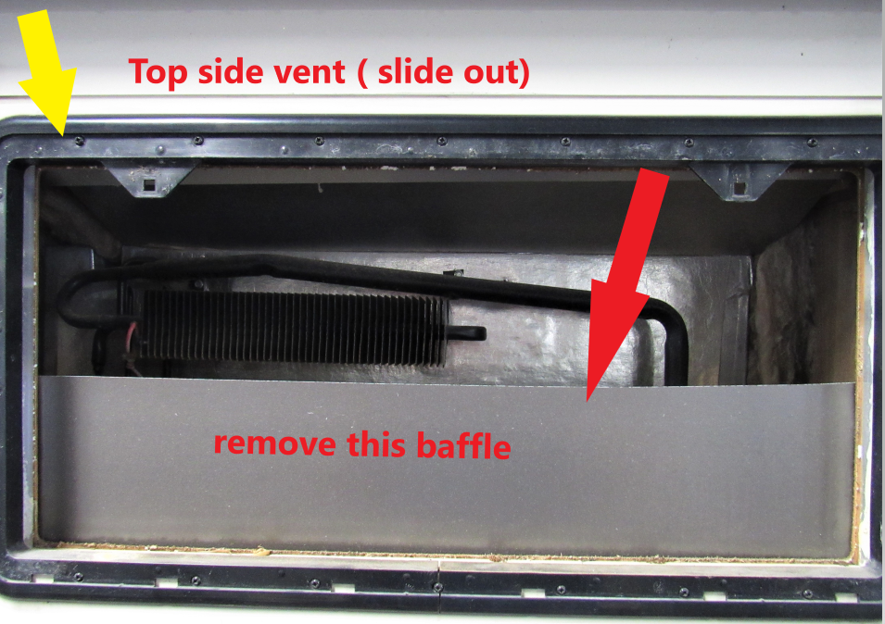
Now you’re ready to slide the refrigerator back into the cavity. Once it’s started it helps to have someone outside to watch as you slowly push the fridge back into place, making sure the gas line is out of the way. Install mounting screws (RA)on the top and bottom first before finishing outside.

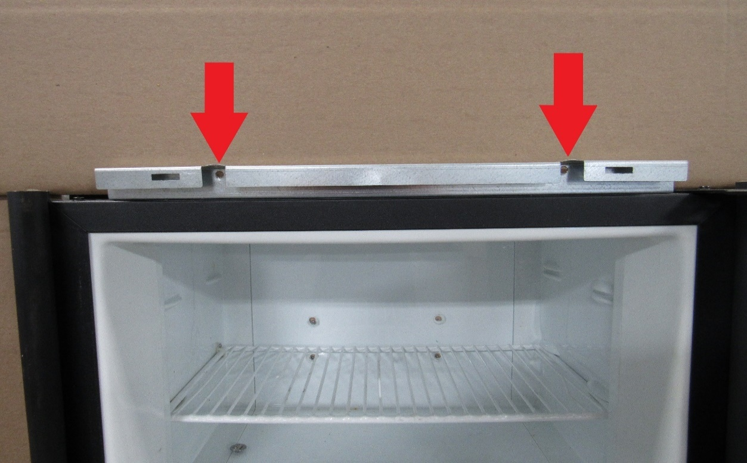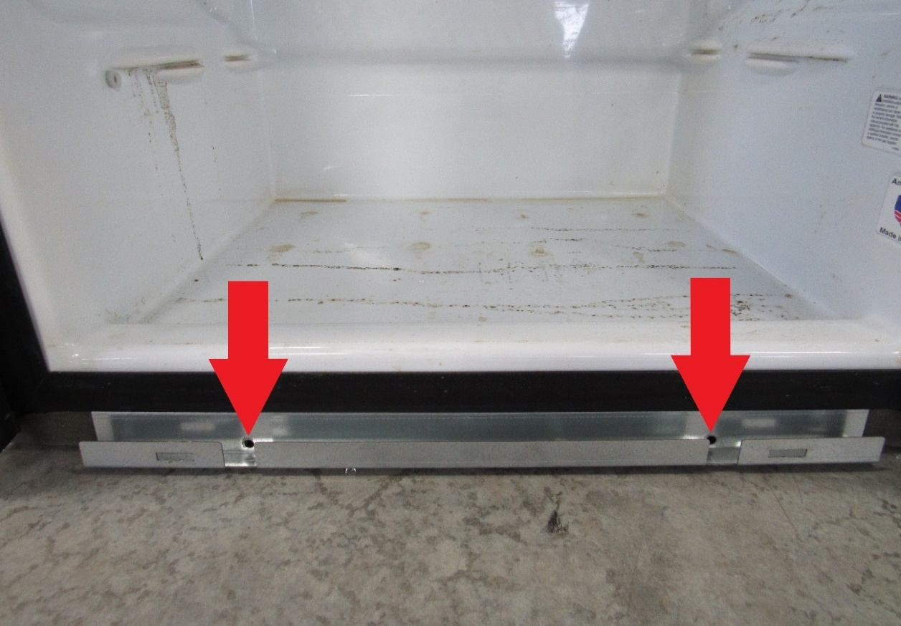
Attach black trim pieces on top and bottom.

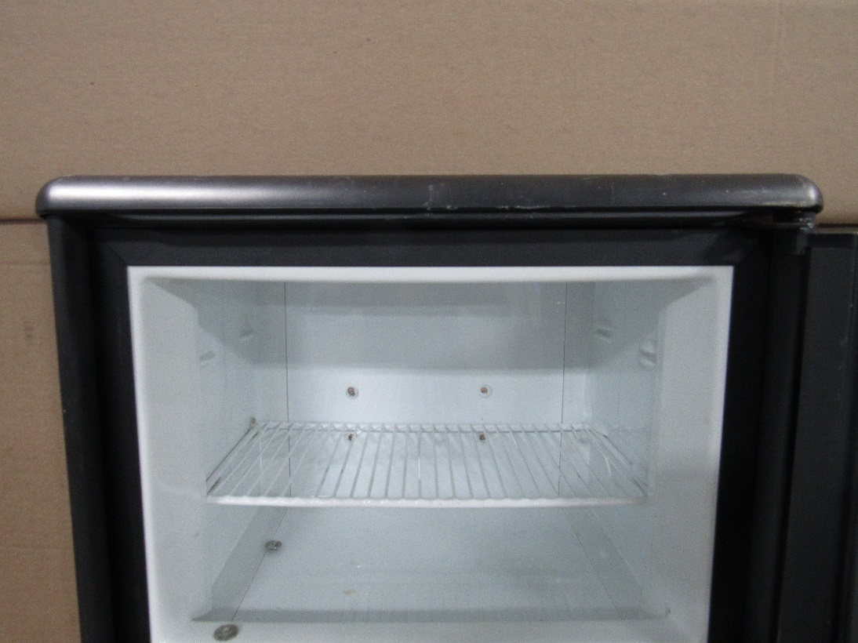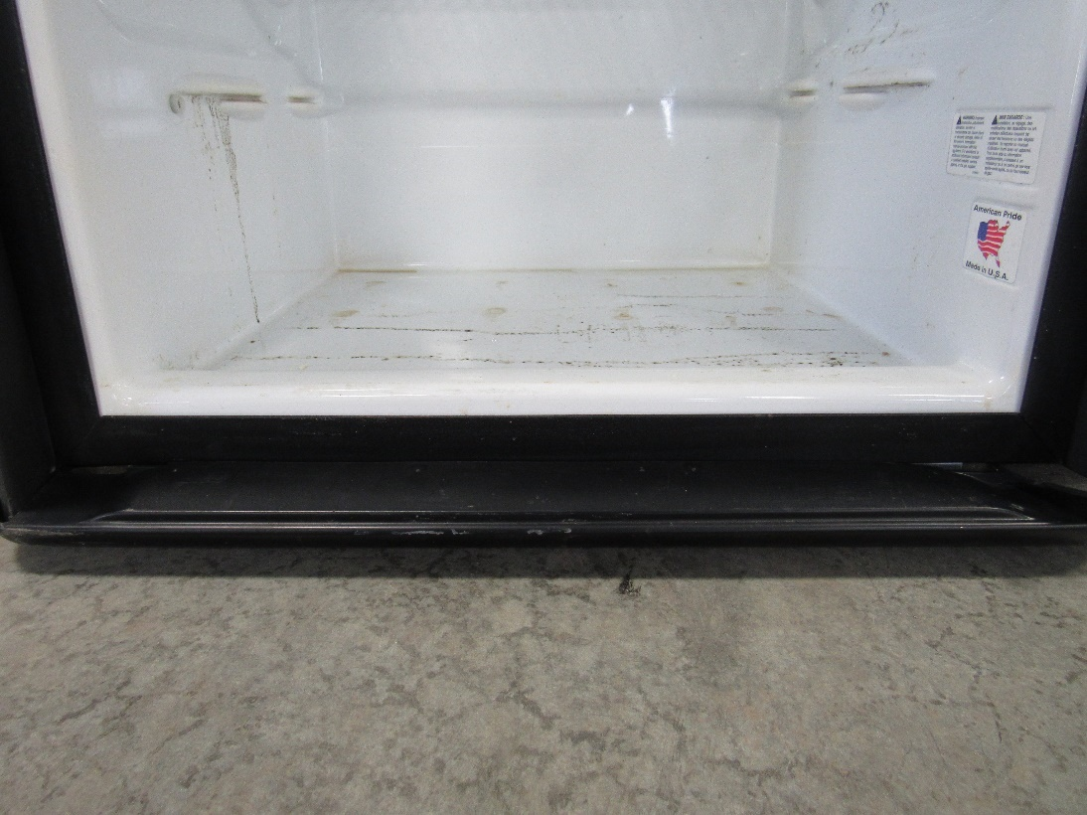

Now we are ready to finish the outside. Put the two mounting screws (RA) back in place. Or if your coach is a Winnebago, see pics above for location of bolts,
Warning: make sure this hook up is followed carefully, your coach Positive needs to go to my Coach (+) Red
Plug in your coach 12V Power wires. Make sure you know which is the Positive + and Negative - The color of the DC 12V wires will vary from one RV to the next. The compressor has a low voltage shut off set at 10.4V so if your wire size is not big enough to handle the kick load a 10 ga wire may need to be added to help carry this load
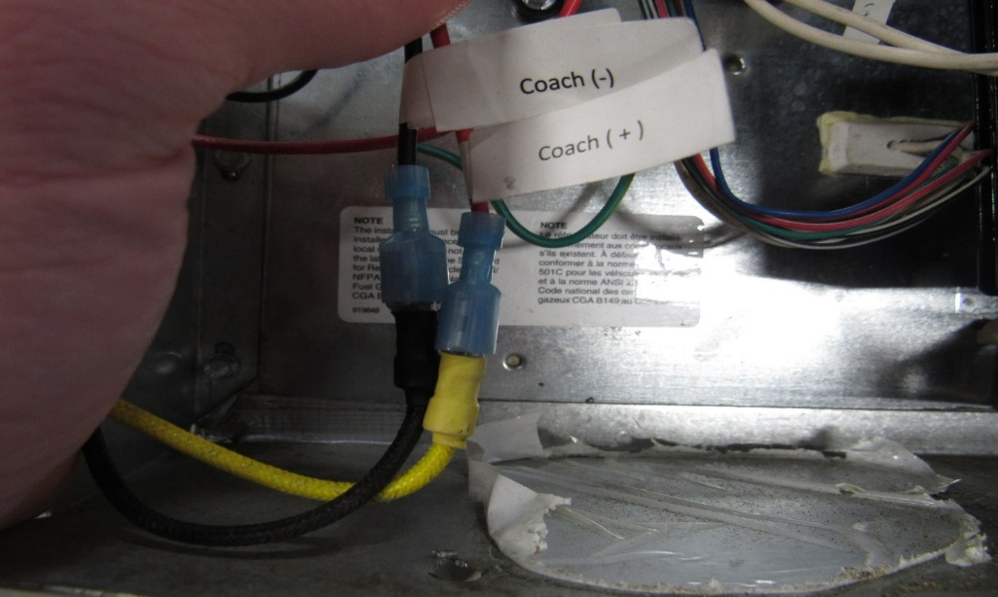
WARNING:
Make sure this step is properly followed and leak checked so you don’t have a gas leak
Thread gas plug into gas line (plug included) use wrenches to tighten in, after its tight, gas tank is ready to turn back on and using a soap water mixture check for leaks. (RA) this copper tube can be bent carefully and tucked out of the way once the fridge is back in place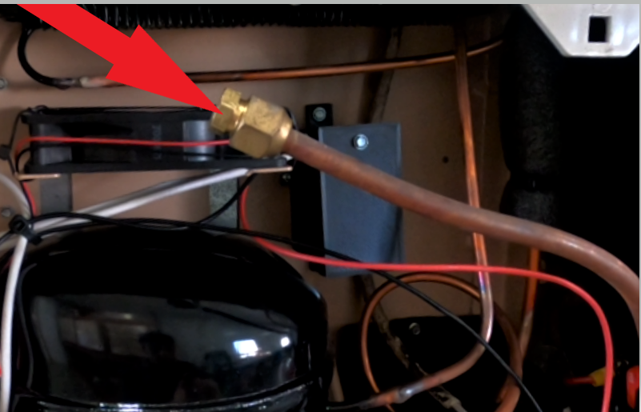

Go to the inside of your RV and turn your refrigerator control “ON”. (RA) Now set the mode (YA) onto LP mode. After a few seconds your compressor should start up and run, you can now adjust your temp setting (BA) to your desired temp, we recommend setting it on 2 if your display matches Image 1. Or 4 if your display matches Image 2. Then after approx. 6 hours, adjust up or down to your desired temp inside the fridge. Note: Food safe zone is 38F to 42F, however, optimal temp is 34-36 degrees F in the fridge and 0-10 degrees F in the freezer.
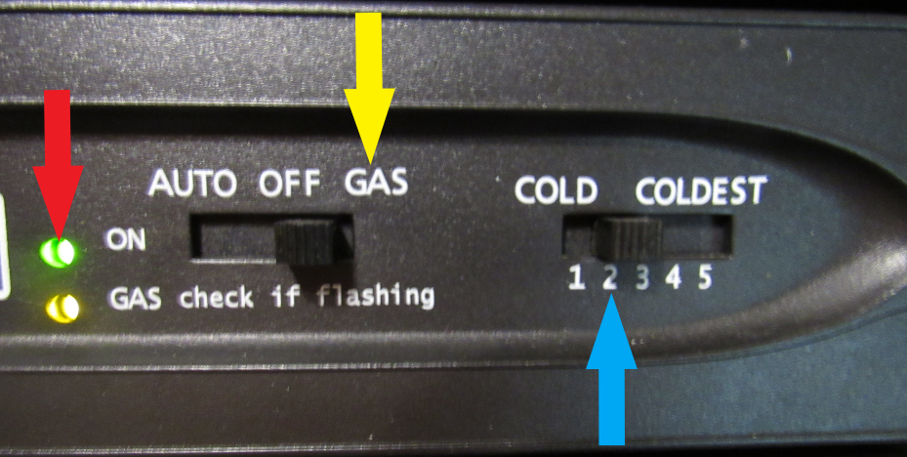
Image 1
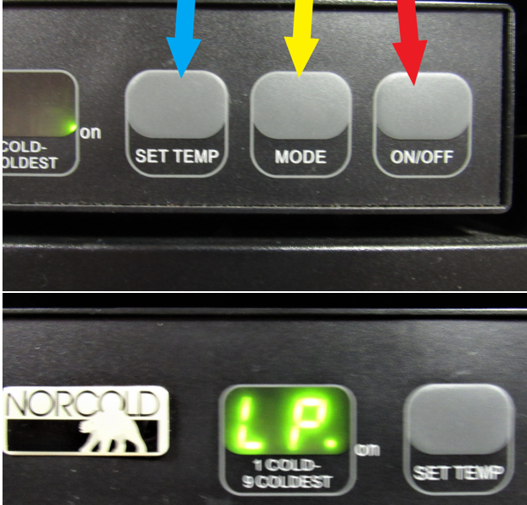
Image 2
We highly recommend using a digital wireless thermometer to monitor your inside fridge temps, many phone calls or temp misleading’s can be avoided by making sure the thermometers you are using are accurate. You do not have to use our brand but we do recommend using something similar to this type.
https://jc-refrigeration.com/product/refrigerator-freezer-digital-wireless-thermometer-free-shipping/
Use digital wireless DO NOT USE
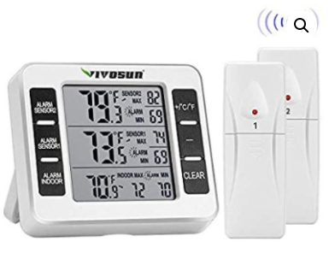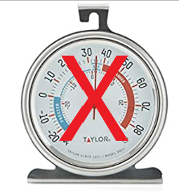
Clip the sensor for the fridge on the bottom side of the first shelf beneath the fin, place it so the sensor is centered, front to back and side to side (RA), if its clipped underneath it will be out of the way and shouldn’t interfere with storage.
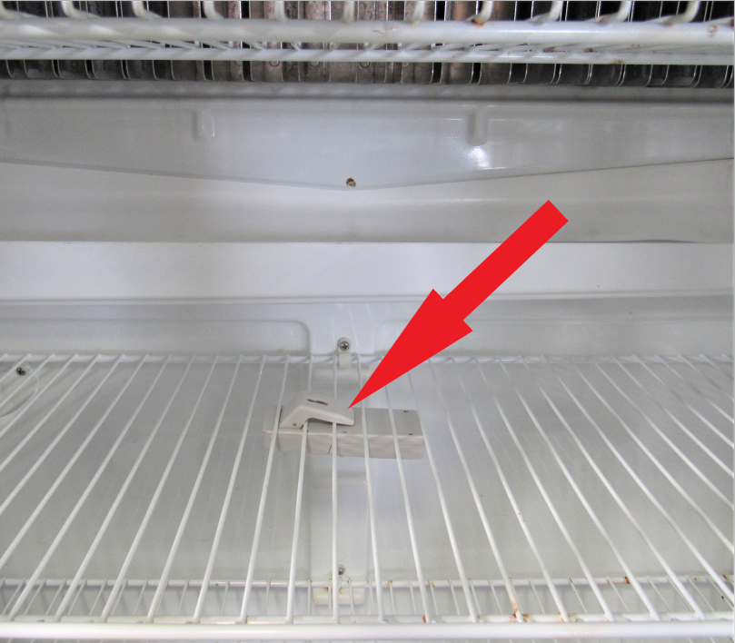

The same applies the with freezer. Clip the sensor underneath the shelf, centered from side to side, but have this one more towards the back of the freezer.
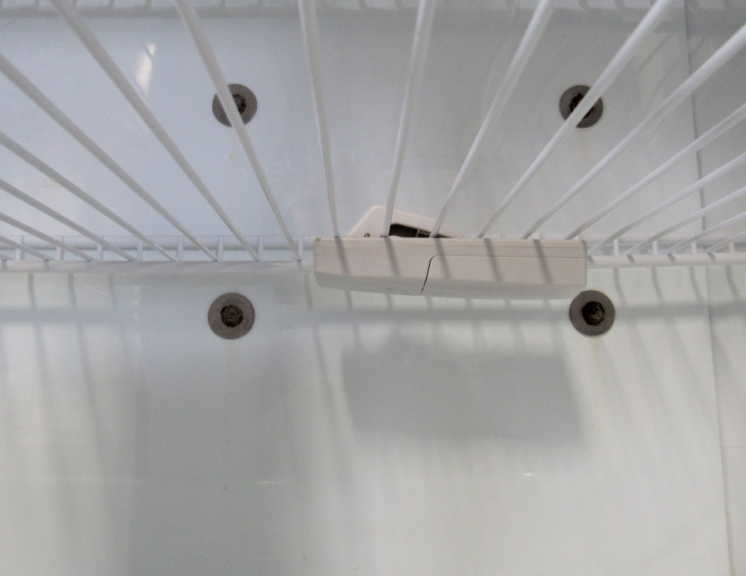
*Troubleshooting*
12V Model only: If compressor starts but shuts back down after 15 seconds, check your voltage at the compressor at the time it tries to start. Compressor has a built-in low voltage shut off set at 10.4V and on startup is when the compressor will draw the highest amperage. So, if voltage drops below 10.4V, the compressor will shut down. The higher the voltage the lower the amperage, or vice versa, so in order to have compressor running the most efficient the voltage needs to stay above 12V while running. So, make sure that your batteries are not too low.
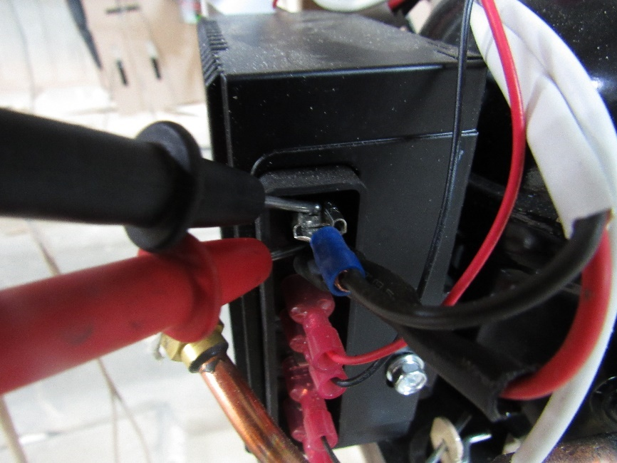
Error Codes:
“SR”: Check your fridge ground wires and try grounding a wire from the fridge box to your gas line.
“NO FLO” or “No FL”: #1Check fridge ground wires. #2 Open controller cover and make sure wires are all intact and not broken #3 make sure the relay makes a “CLICK” after it’s turned on. #4 Make sure igniter screw is not touching ground or wet, turn out 1 full round. #5 Flame rectification wire may need to be changed. See Controller below.
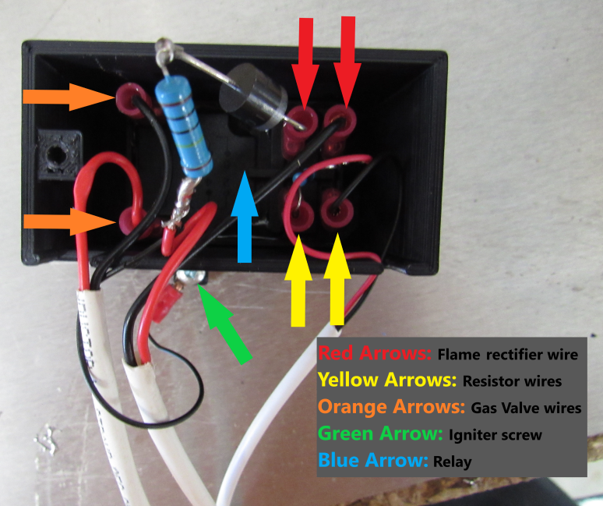

“NO CO “Code
This code will shut down the control board and a restart is needed, see diagram below how to restart
-Remove board cover and remove all wires except the 12V power wires and the gas valve wires going to the controller.
-Take a 18ga or smaller wire and strip back both ends at least 1 “, make sure 12V power and gas valve wires are hooked up, then push one end of wire in empty slot (YA) and hold other end of wire onto a ground, either back of fridge box or ground from coach, after approx. 5 seconds you will hear a click and you can take wire back out and put cover back on as well as other wires and your fridge should function as normal again.
Resetting Control Board
(Find the board style that matches yours)
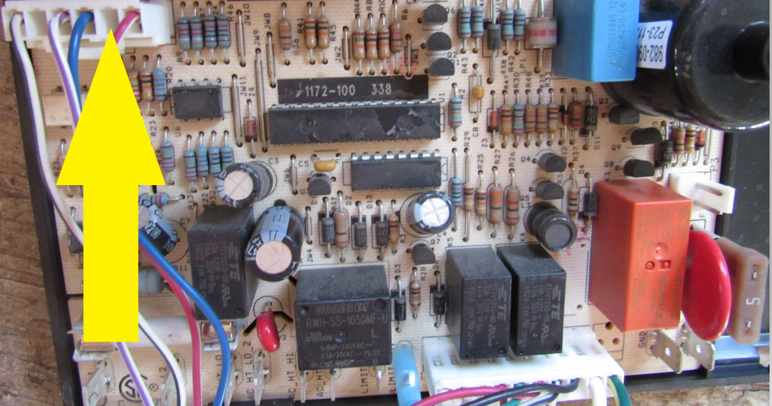
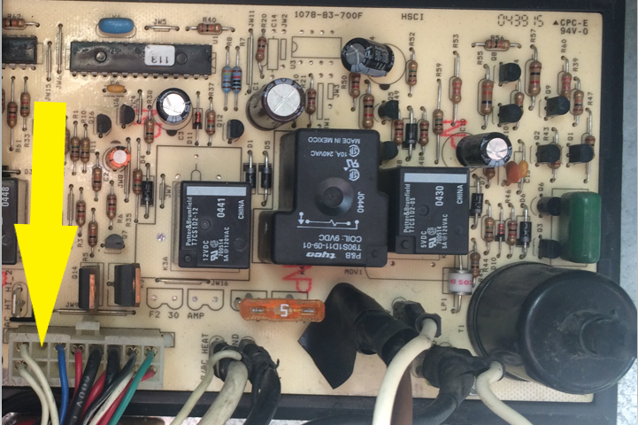
If you can’t get an error code fixed or can’t get the cooling unit to run, you can always wire the compressor directly to power. Below you will find instructions on how to do this. Follow the directions for the model you have, either 12/24V or 120V.
HVAC Direct Wire 12V
Tools needed:
Step 1: You will need a screw gun with a ¼ inch hex head bit to remove the screw that holds the cover of the black controller box on. (Red arrow)
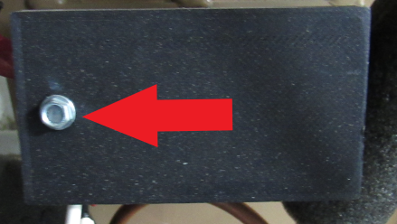

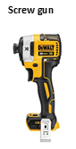
Step 2: Locate the red and black wires inside the controller that control the on/off of the compressor. (One of the wires will have a small blue resistor soldered to it. See image #1 below.)
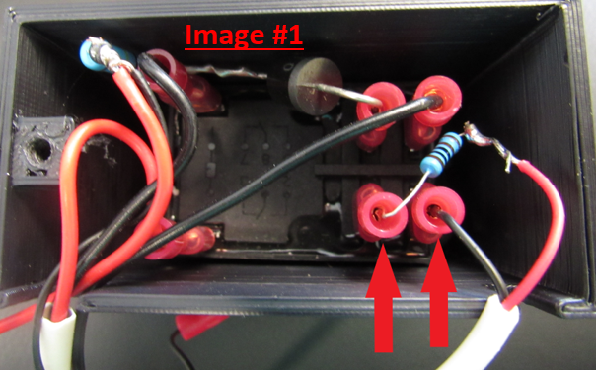

Step 3: Take a piece of wire, 22-gauge (or smaller), approx. 3 inches long, and strip ¼ inch off of each end.
Step 4: Insert one end of the wire into the connector where the resistor is plugged in to. Insert the other end of the small wire into the opposite connector (see image #2 below) and the compressor should turn on. 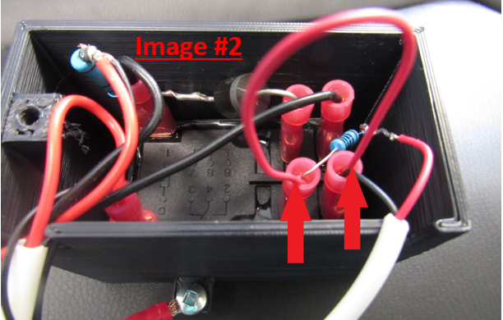
Notes: There is no voltage going through these wires so you don’t have to worry about getting zapped. To make sure that the compressor is wired directly, go to your front display panel and hit the power button to turn the fridge off. Then go back outside and check to see if the compressor is still running. If the compressor is not running, then your jumper wire isn’t making good connection with one or both of the connectors inside the controller box.
Fin fan Operation
The fin fan should remain running whenever the fridge is powered on. If it is not, try flipping the switch on the fan to the opposite position to see if it will operate then. The normal position for the fin fan is to have it centered on the fin (left to right and also up and down) However, if you have frost starting to build up on one side or the other of the fin fan, move the whole fin fan over so that one of the small fans is positioned directly above where the frost buildup is.
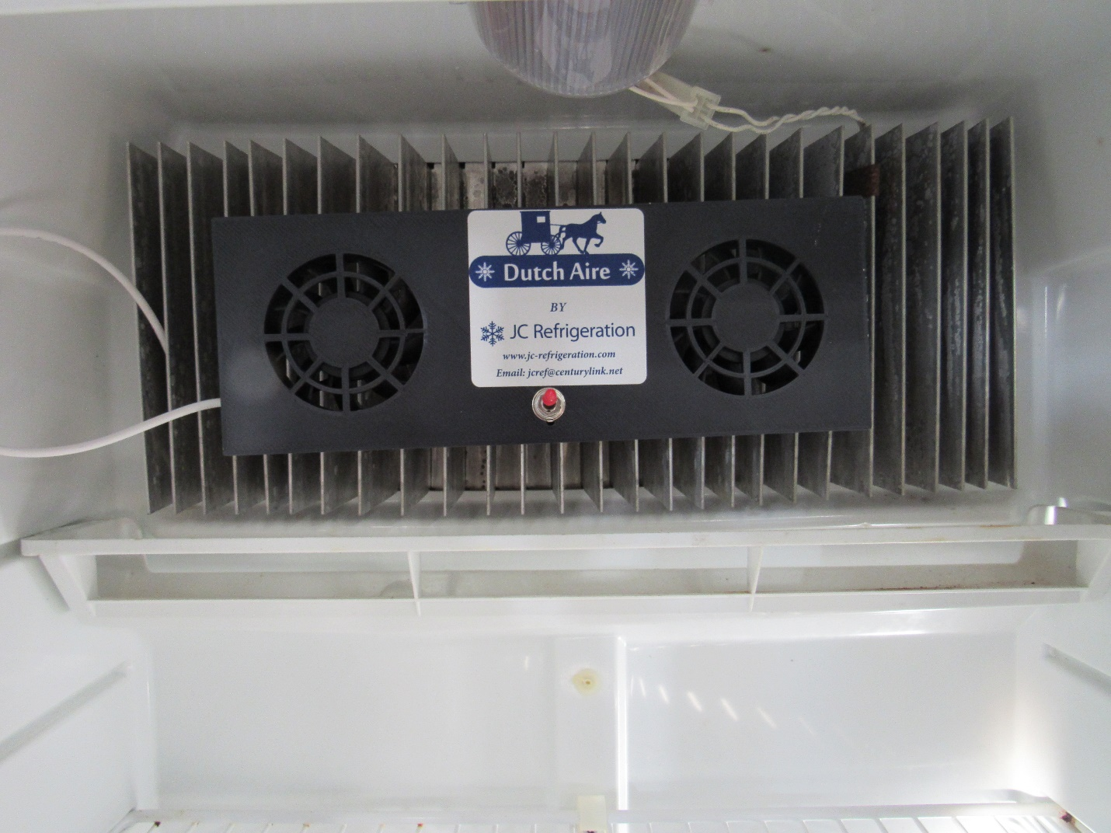
Note: If you installed an adjustable thermistor, your temp setting on the front display panel will still be in effect as well. A good starting point is to set the front display to 2 (if your model has 1-5) or 4 (if your model has 1-9). Then set the adjustable thermistor to the middle setting (12:00) and let the fridge run for at least 6 hours then make changes on the adjustable thermistor inside to dial it in to your desired temp.

FAQs
How much will the compressor actually run?
From our testing in 80 degrees, with the fridge and freezer empty, and the doors remaining closed for a 24-hour period, the 120V AC compressor will run approx. 56% of the time and the 12V DC compressor runs approx. 67% of the time. However, keep in mind that this can be very easily affected by a number of variables such as ambient temp, how often the doors are opened, and how much food is in the fridge/freezer.
What is covered under warranty?
Our warranty covers the cooling unit and any of our controls that came with the cooling unit. It does not cover any original Norcold parts such as the control board, the front display, thermistor, etc.
What if the cooling unit needs to be worked on and I’m not close to your location (Shipshewana, IN)?
Contact us first and we will try to help you get the issue resolved. Most problems can be fixed by us through email or phone but if more work, or hands on work is needed, we have a list of dealers/service centers in almost every state that have purchased cooling units from us before and could possibly help you out.
Is there any regular maintenance to perform on these cooling units?
The only thing that needs to be done on these cooling units is to take compressed air and blow any dust or debris out of the condenser fin. This can be done maybe once or twice per year.
