Relay Kit Installation Instructions
Below is a picture of all the parts of the relay kit.
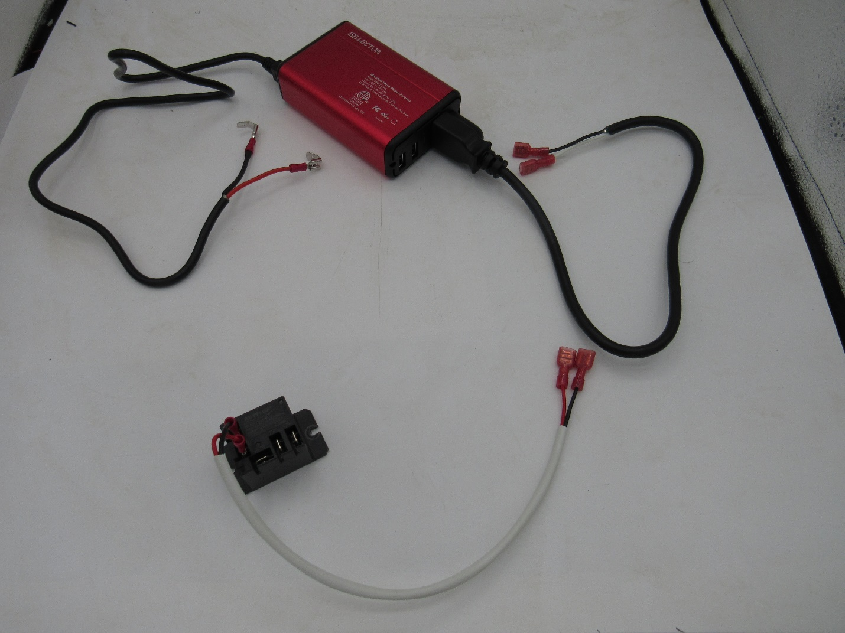
This relay kit is used when your existing Dometic control board does not accept 12V power going thru the AC side of the board. So, in order to keep everything 12V and not have to use your 120V coach power, we run 12V through a little inverter that inverts it to 120V and sends a 120V signal into the control board. This inverter does not create an extra power load, all it does is satisfy the boards 120V need. When the thermistor tells the control board to turn the cooling unit on, it sends 120V power to the AC Heater spades on the control board which will then activate a relay which has your 12V + from the coach and the 12V + wire from the compressor plugged into it. Once the relay closes the compressor will start up. So below are step by step instructions on how to install the relay kit.

#1: Splice into your coach 12V power using the piggy back connectors shown in the picture below. This will provide 12V power to the inverter. Red wire is positive and black wire is negative.
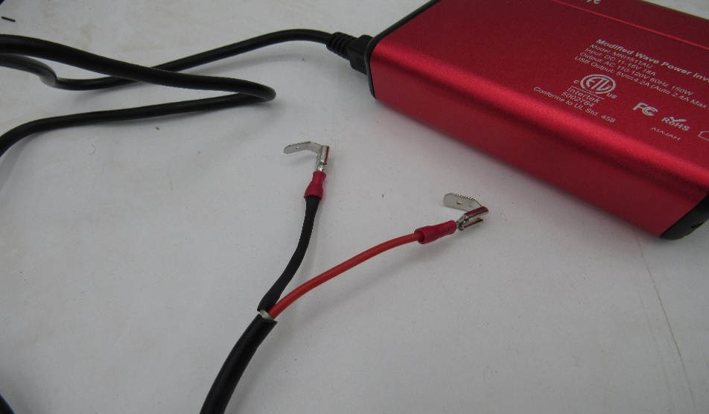
#2: Now plug the 2 female connectors (Red arrows in the picture below) on the 120V wires that come out of the inverter, into the control board. On the next page are 2 examples where they get plugged into the control board, however, there are different styles of control boards available so yours might not look the same. Just make sure that it gets plugged into the AC line/120V line spades.
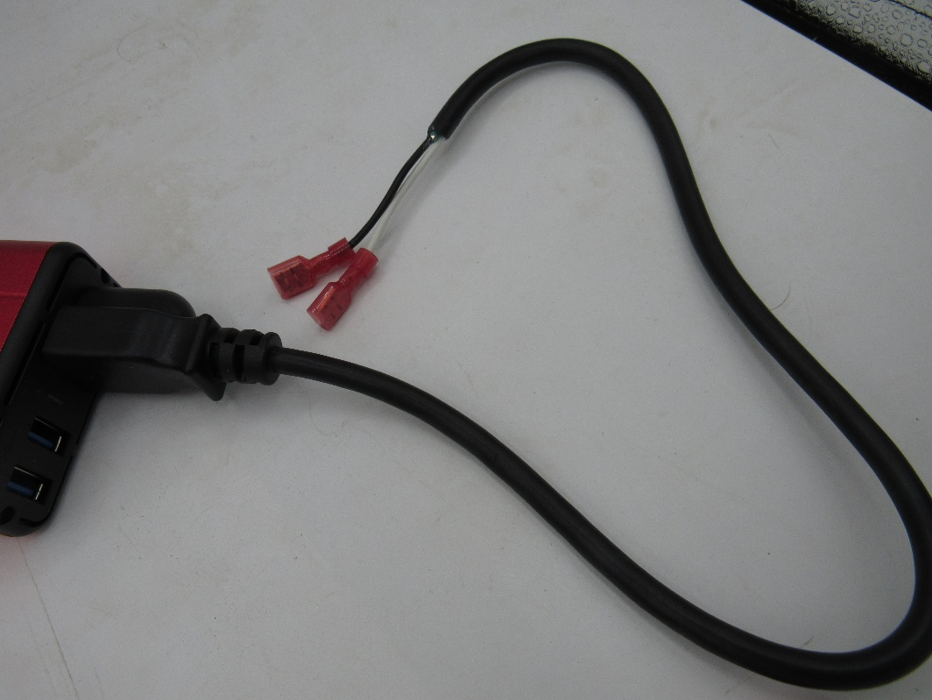
Red arrows are pointing to AC/120V in spades. (Inverter)
Yellow arrows are pointing to AC/120V out spades ( Relay)
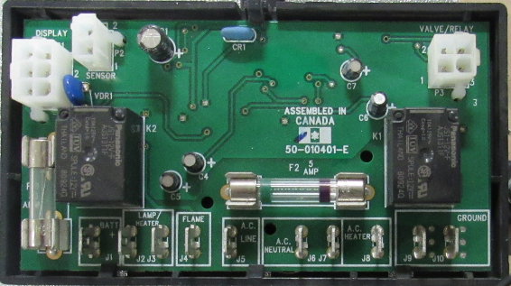
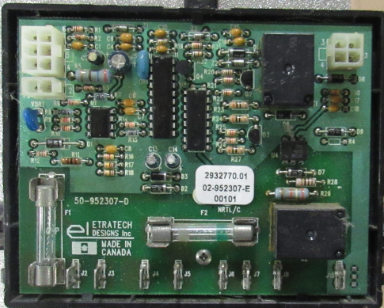

#3: Take the 2 red female connectors (Red arrows in the picture below) coming from the relay and plug them into the control board where your electric heating elements used to be plugged in to. Refer to the yellow arrows on the previous page for an example of where they get plugged in to.
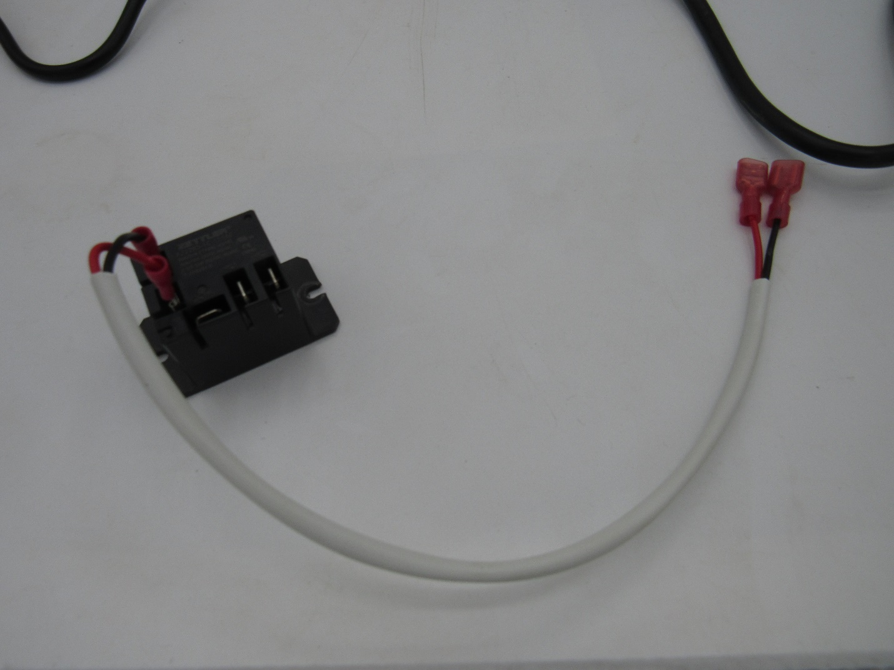
#4: A 12V + wire from your coach power will then plug into the black relay in the location shown in the picture above with the yellow arrow. Then take the red and black wire from the compressor and plug the red into the relay in the location shown above with the blue arrow. The black wire from the compressor gets plugged directly into the 12V – from the coach, or a grounding eyelet can be attached and grounded to the fridge.
#5: Turn your fridge on and make sure that it is set to Auto. The compressor and the fan above the compressor should kick in within a couple seconds.

